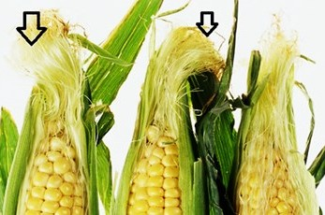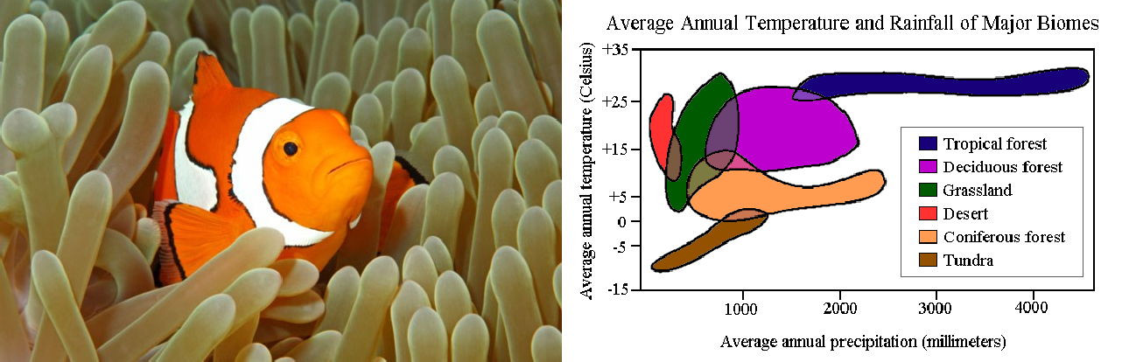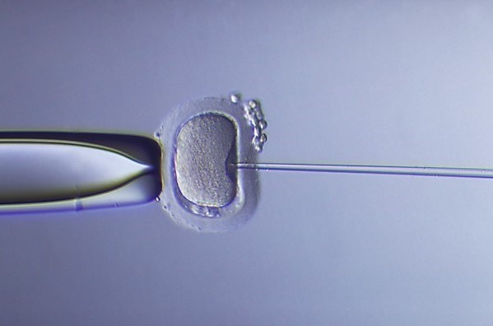

Diagram Based Questions in Biology

Class
XII

Reproduction in Organisms

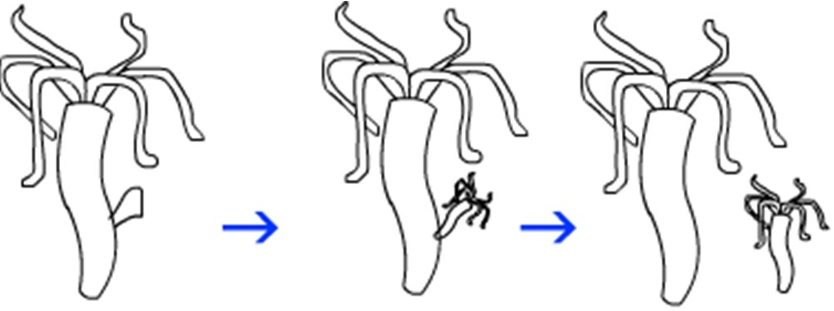
  - a) Name the type of asexual
reproduction shown in the figure below.
b) Name any organism where such type of asexual reproduction takes place.

  - a) Study the diagram and label-A.
Which group of fungi does it belong to?

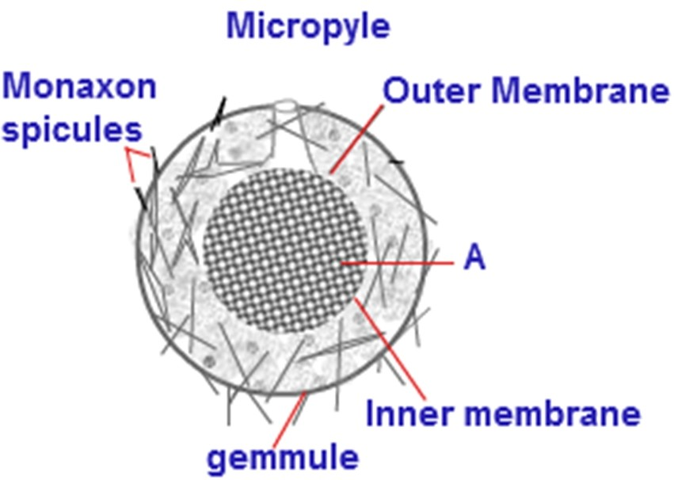
  - a) Name the organism where it is found.
b) Label the part A

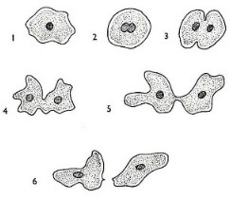
  - The diagram shows an event in Amoeba.
    - What is the event?
    - Are the two cell in stage 6 identical?
Name any other organism where such type of event occurs.

http://www.biology-resources.com

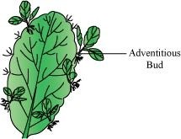
1.5
Name the plant.

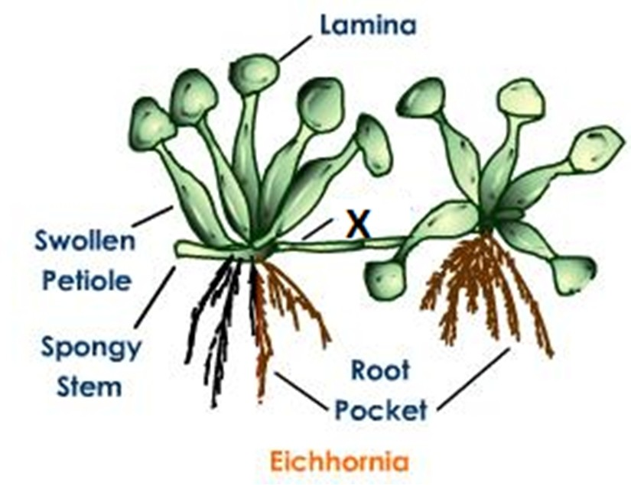
  - a) Name the type of propagule ( marked X)
b) Name any other plant propagated by the same way.

http://images.tutorvista.com/content/angiosperm-morphology

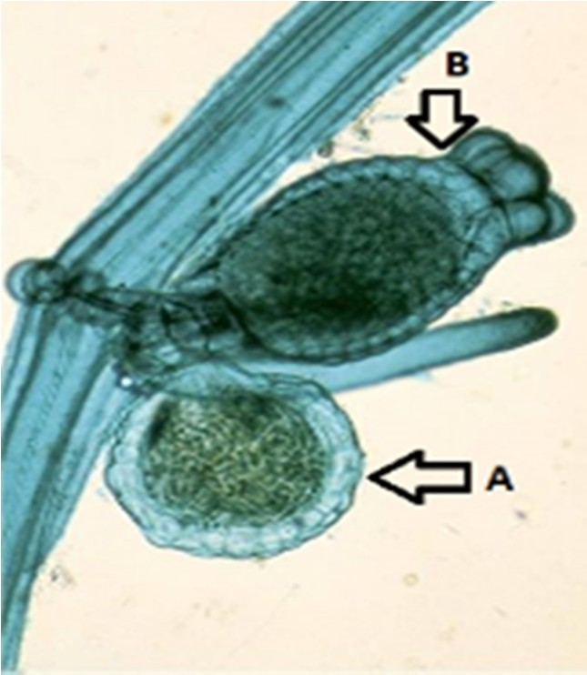
  - The image shows Chara with reproductive organs. Identify the organs marked A and B

https://fbcdn-photos-e-a.akamaihd.net

  - 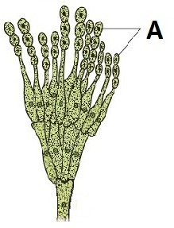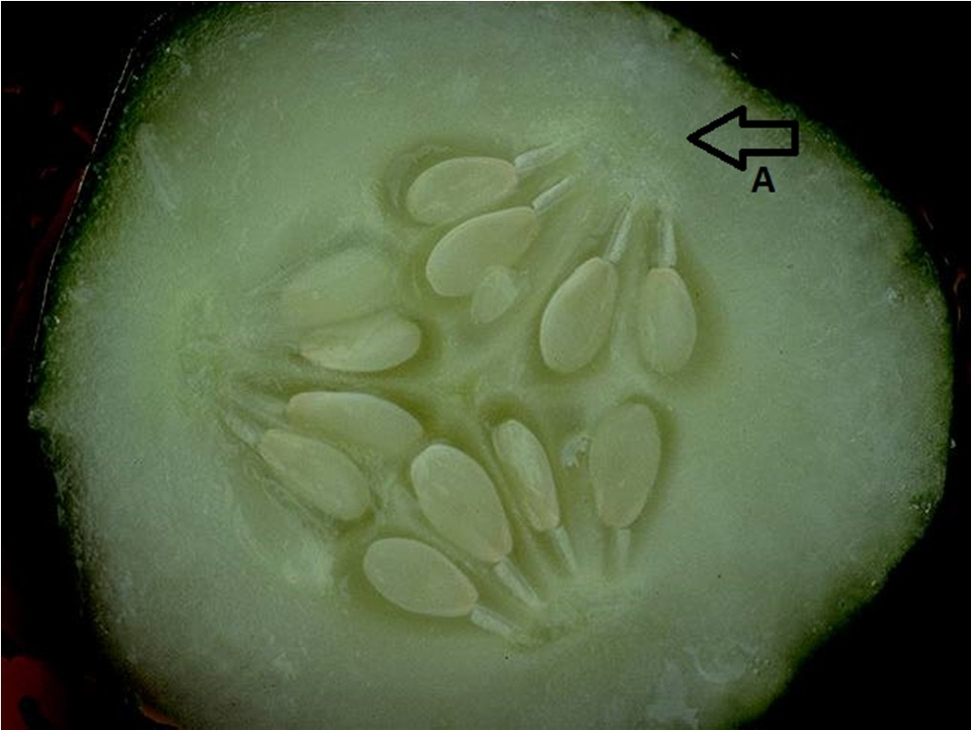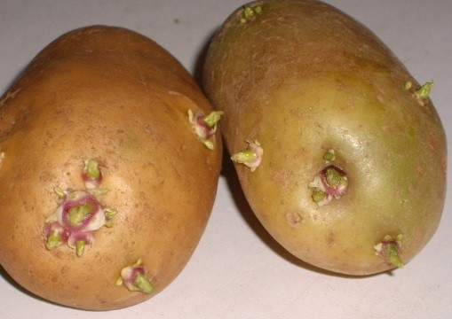The photograph shows TS of a cucumber. Seeds
are visible in the centre. Name the part of the fruit marked ‘A’.

1.9
The image shows potatoes with eyes.
    - What are the eyes?
    - What are the eyes used for?
    - Which part of the plant is the potato?

1.10

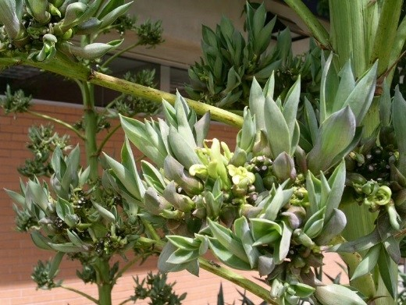
See the photograph carefully and answer the questions.
    - Write the typical term given to the bud like structures.
    - Name the plant http://www.public.asu.edu/~camartin

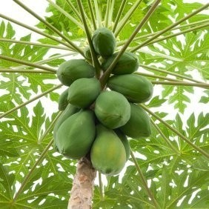
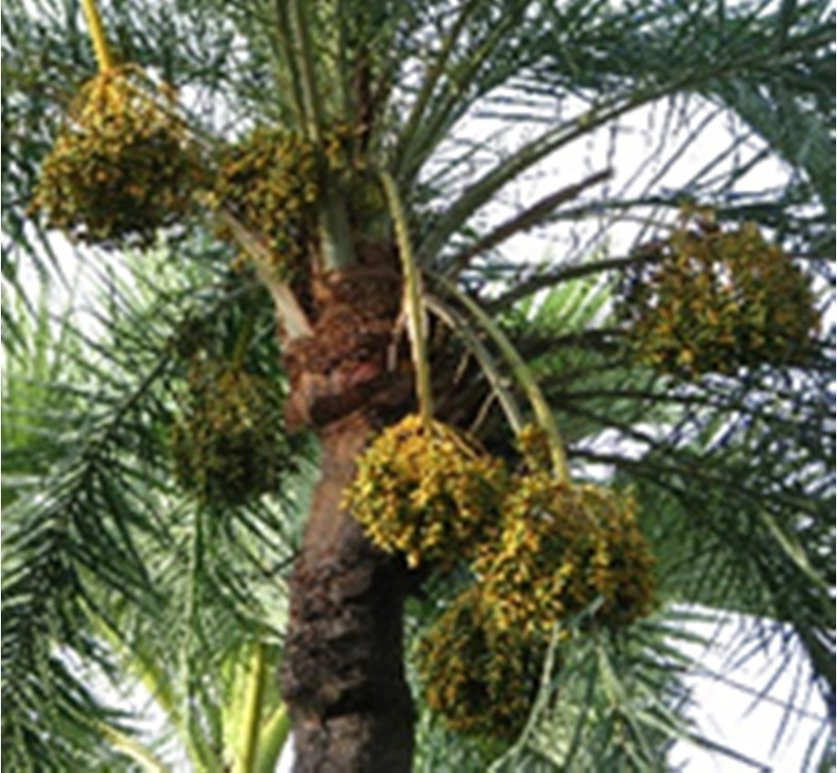
1.11

Both the plants are (chose any one). Define both the terms. Suggest any other terms meaning the same for them.
    - Monoecious
    - Dioecious

- Sexual Reproduction in Flowering Plants

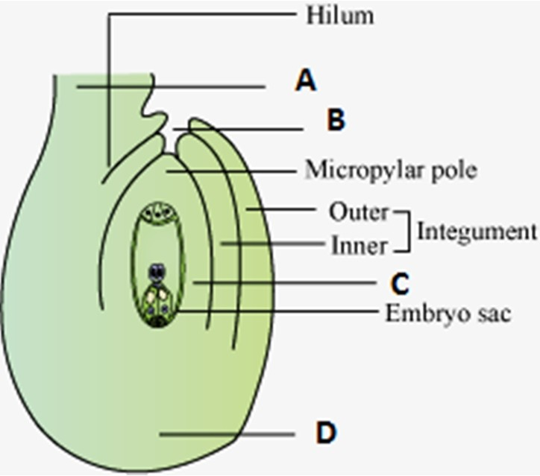
  - What does the diagram represent?
Label A-D
*Draw any other type of ovule if known to you?

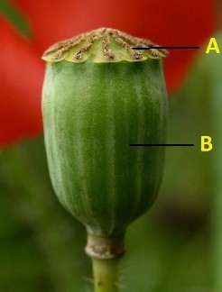
  - This is a part of a floral part of Papaver. Identify the parts A and B.

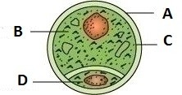
  - Identify the structure and label A to D.

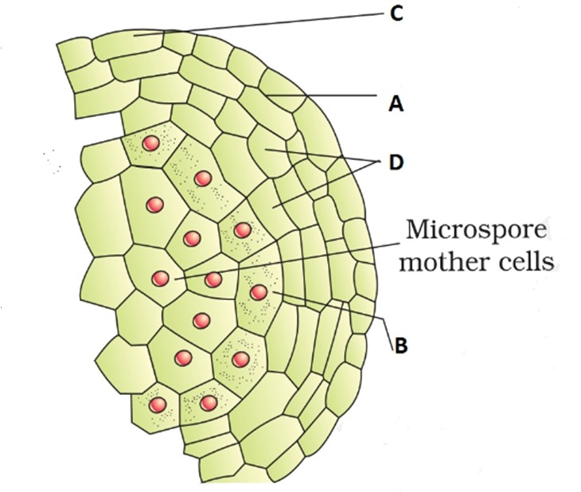
  - The figure shown is a portion of TS of angiosperm anther. Label the parts A to D.

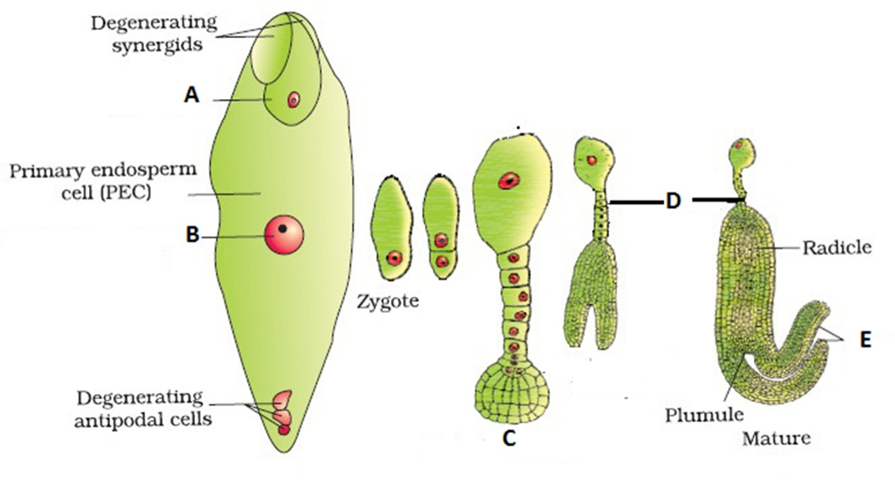
  - a) Study the
diagram and label A to E.

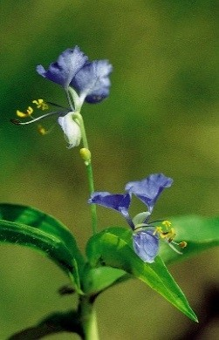
2.6
This is a photograph of Commelina sp. bearing flowers. What is the specialty of the flowers borne on this plant?

http://idao.cirad.fr/content/oscar/especes/c/comdi/comdi_04.jpg

2.7
Study the diagram and answer the following questions:
    - Which type of cell division occurs in the diagram marked A
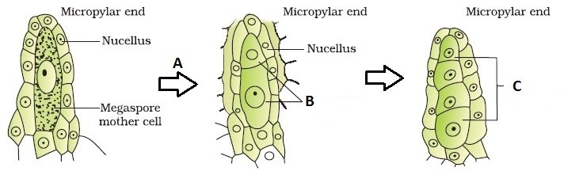
    - The two cells formed in B is called
    - In figure marked C, four cells are formed. What are they?
    - What happens to the cells marked C?
    - What is the total process called?

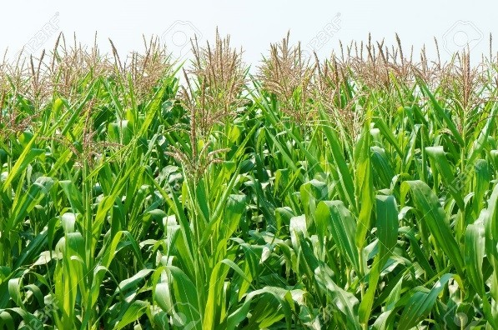
  - a) Name the agent of pollination for
these plants
b) Write the characteristics of such flower.

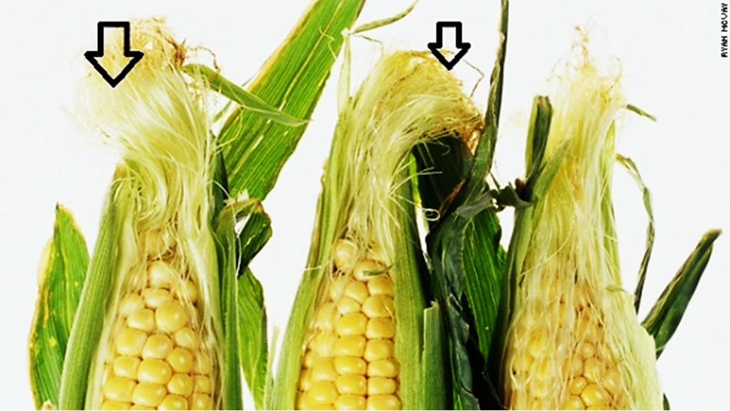
2.9
    - Identify the silky tassel marked in arrows.
    - What type of pollination is expected in this plant?

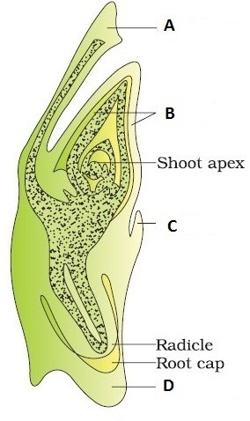
  - Study the diagram and label the parts A to D. Identify this diagram.

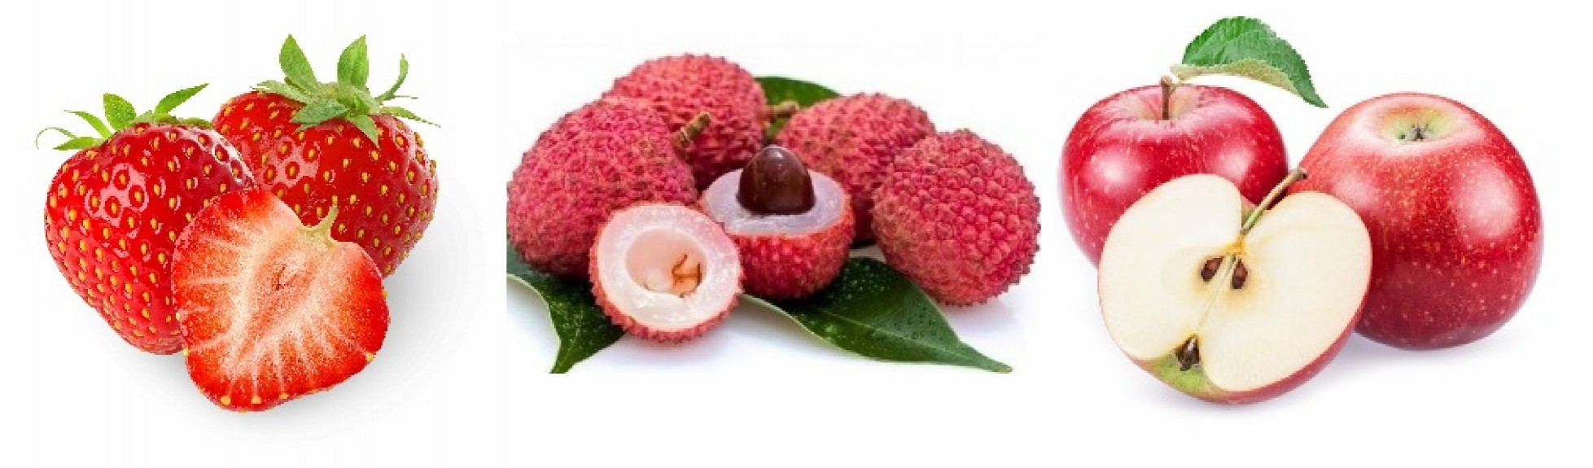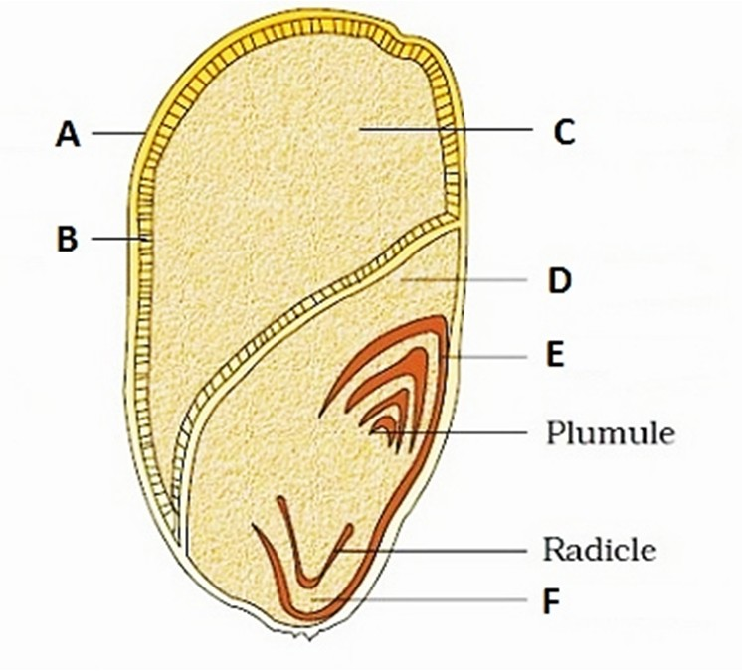2.11
The diagram shows LS of a Maize seed. Label A to F.

  - 2.12

    - What is common to the three fruits in being called fruit.
    - Name the edible parts of the fruits

Human Reproduction

3.1
Label the parts A to D.
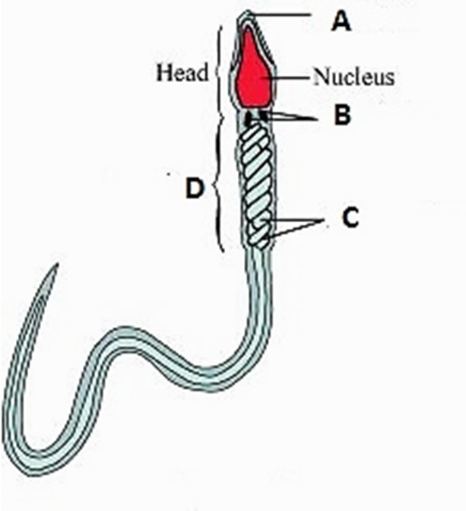
What is the role of the part marked ‘C’?

How many sperms are present in a single ejaculate?

http://img1.mnimgs.com
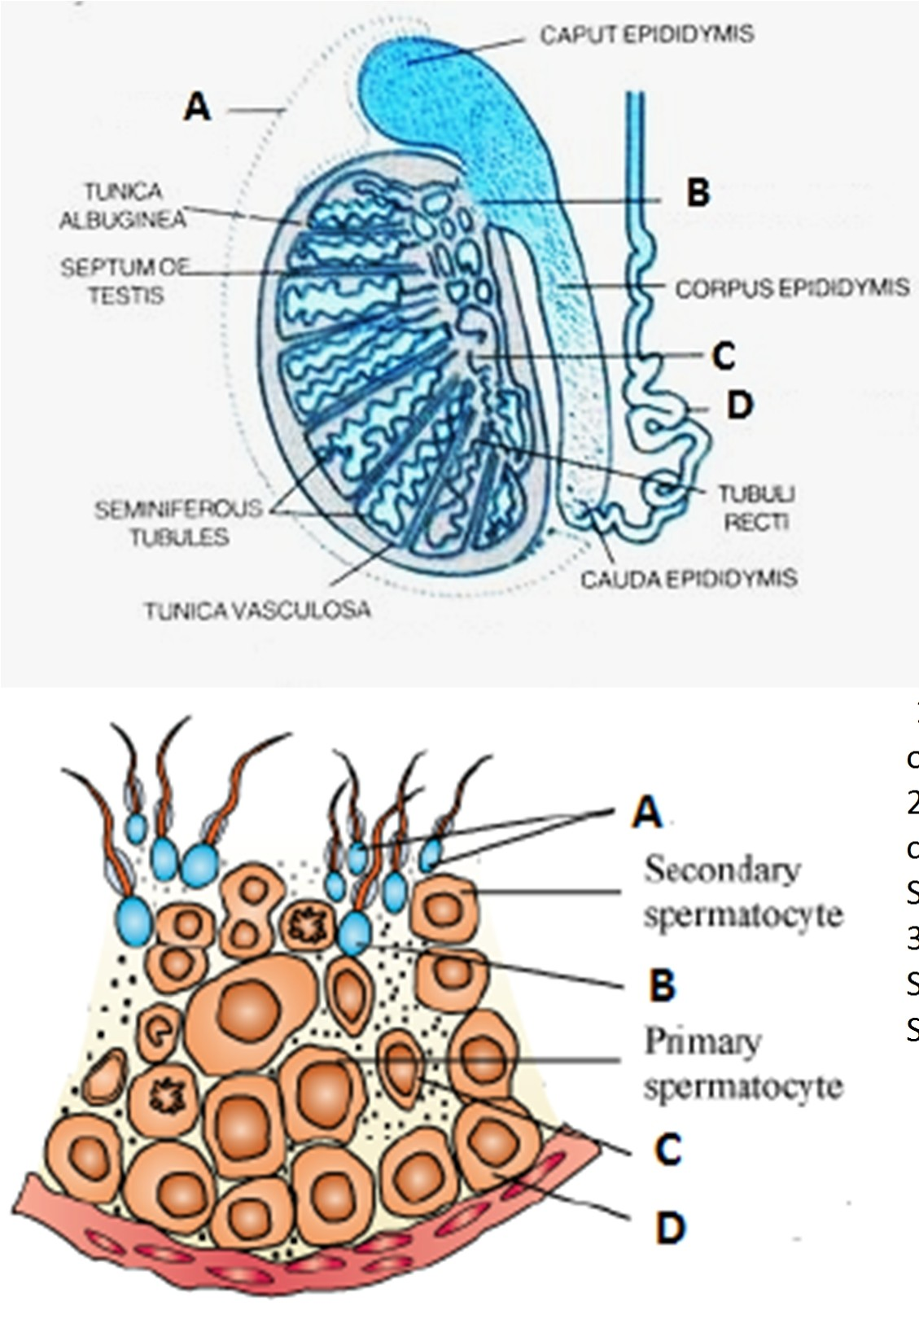
  - The diagram shows LS of human testis.
    - Label A-D.
    - How many lobules are found in each testis?
    - Trace the path of sperms through the tubules from seminiferous tubule to outside the testis.
    - Where are sperms stored temporarily?
    - Where are leydig cells located? Mention their function.

  - 1. This is a part of The Seminiferous tubule
of human testis. Label A-D.
  - What will be the number of hromosomes in Secondary spermatocyte, permatid?
c
S

S S
  - What do the following terms mean: permatogenesis, Spermiogenesis, permiation?

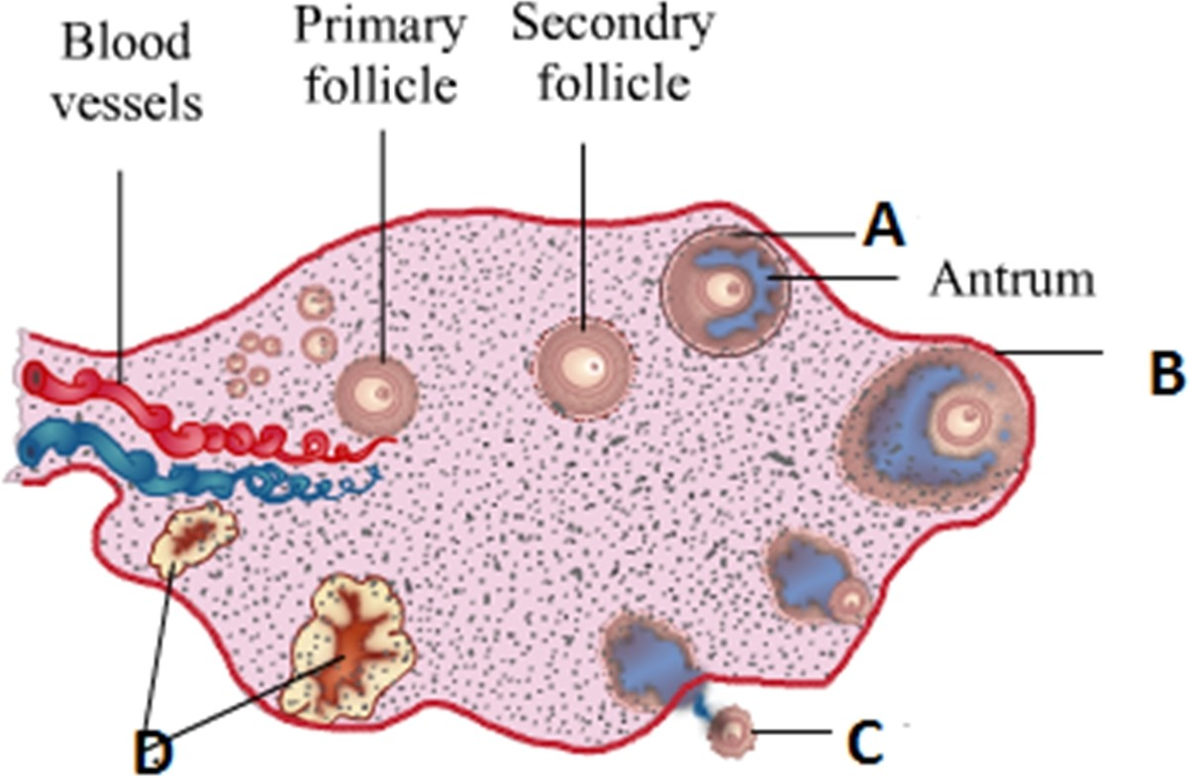
3.4

    - Label the parts A to D
    - How is the tertiary follicle identified?
    - When is Oogenesis initiated?
    - How many primary follicles are present in each ovary during puberty? What happens to the remaining?

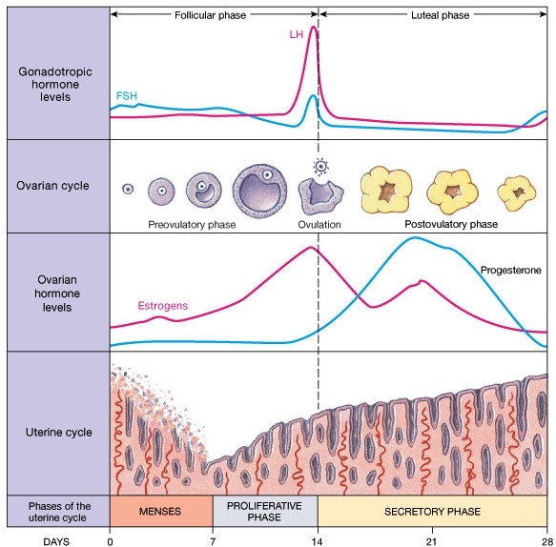
3.5

Study the diagram and answer the following questions:
- On which day the Graafian follicle ruptures to release the ovum? What is it called?
- When does the level of Progesterone rise?
- From where is Progesterone secreted?
- What happens after 28th day of the cycle?
- In which phase of the menstrual cycle the thickness of the uterine wall is maximum?
- If pregnancy occurs, will menses continue?
- What will happen to the levels of Estrogen and progesterone in case of pregnancy?

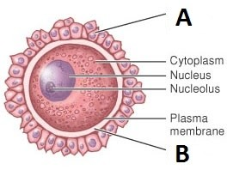
  - What does the diagram represent? Label A and B

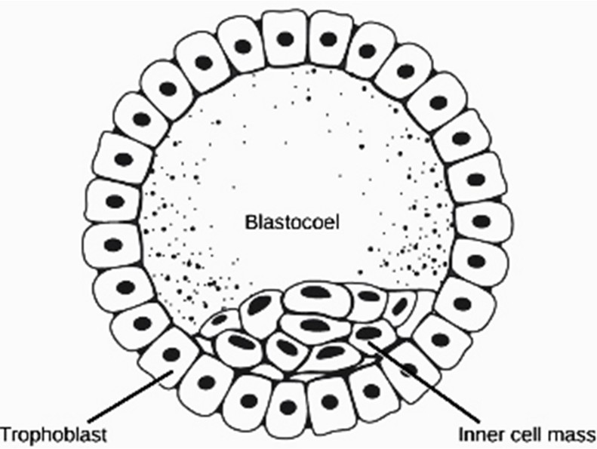
  - a) Name the structure.
  - The embryo with 8-32 blastomere is called
  - What is the fate of the trophoblast and inner cell mass?

5. Reproductive Health

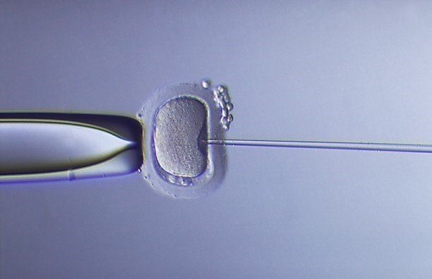
4.1 a) This is a procedure followed in ART. Name the
procedure.
b) Name any other process you can suggest to couples requiring ART.

http://www.gfmer.ch/Livres/FIV_atlas/images/ph17.jpg

Principles of Inheritance and Variation

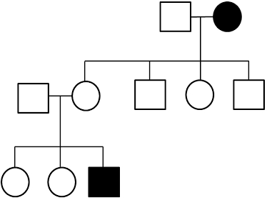
  - Study the pedigree chart and comment whether it is
    - Autosomal or Sex linked
    - Dominant or recessive

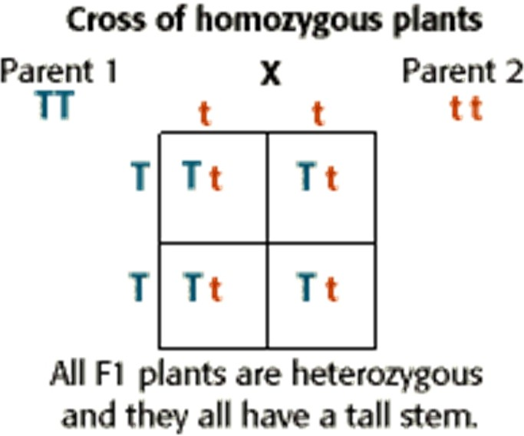
  - a) What will be the Phenotype ratio in F2 generation
- What will be the genotype ratio?
- T and t are separated during gamete formation. What is it called?

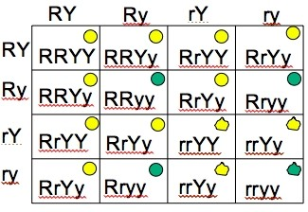
  - http://resources.saylor.org.

Study the table and answer the questions:
    - Name the dominant traits
    - What was the parent genotype if the table shows F2 generation?
    - What is the F2 phenotype ratio? Why did you get such type of ratio?

  - With the help of the diagram answer the following
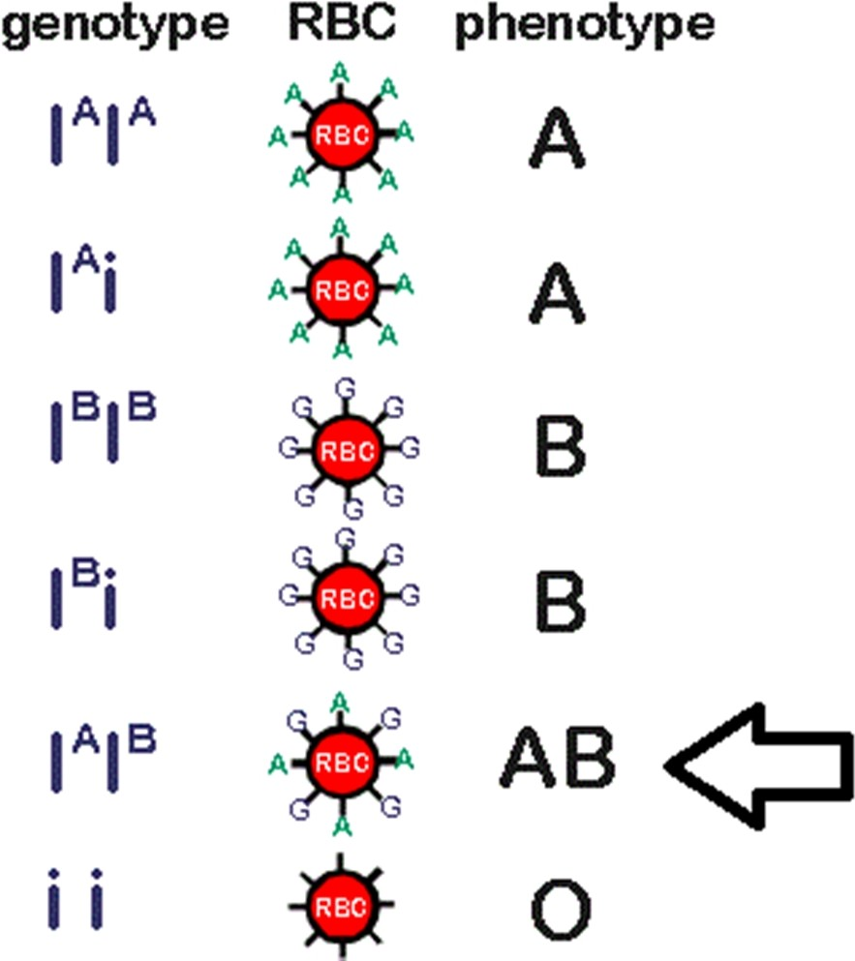
questions:
    - How many alleles are involved in blood grouping? This is an example of .
    - A person having AB blood group has both dominant alleles. What is the inheritance type called?
A man with ‘A ‘blood marries a woman with ‘B’ blood. Can they have a child with ‘O’ blood group? How?

http://blog.canacad.ac.jp/bio/BiologyIBHL1/files/461410.gif

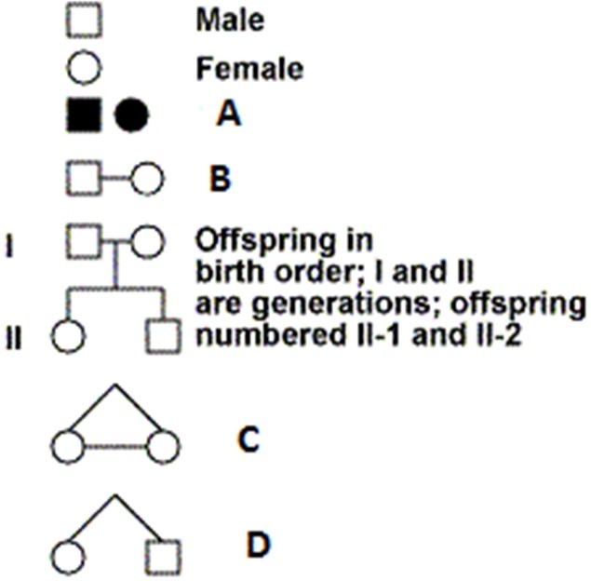
  - The figure shows Symbols used to prepare pedigree charts. What does the symbols A-D represent?

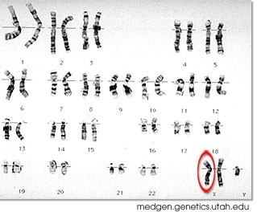
5.6
    - This is a karyotype of a human suffering from certain chromosomal disorder. Name the disorder.
    - Write the symptoms of the disorder.

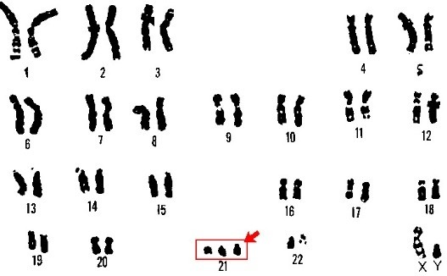
  - a) This is a karyotype of a human suffering from chromosomal disorder. Name the disorder.
  - What is the cause of this disorder?
  - Write the symptoms.
  - By which name is this syndrome also known? Why?

http://dsasdonline.org

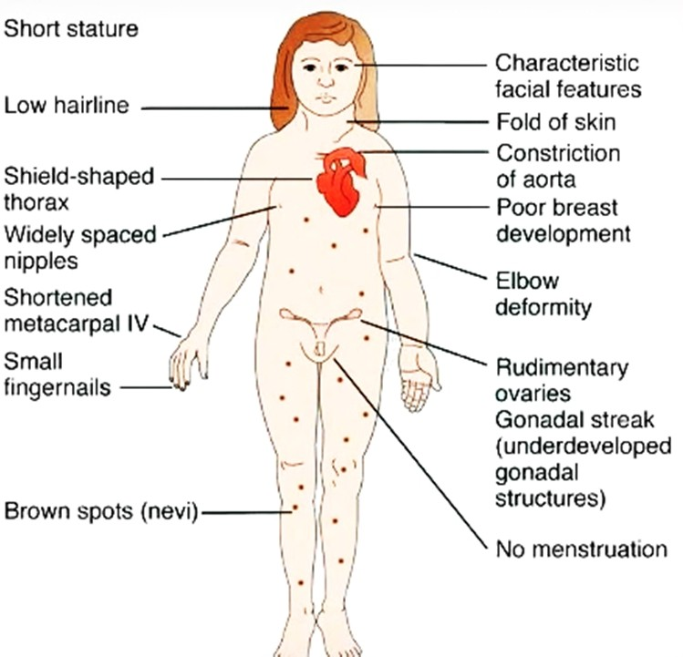
  - a) Name the syndrome
- What is the cause of this disorder
- How many chromosomes (autosome and sex chromosome) do the patient have?

http://medicaltreasure.com

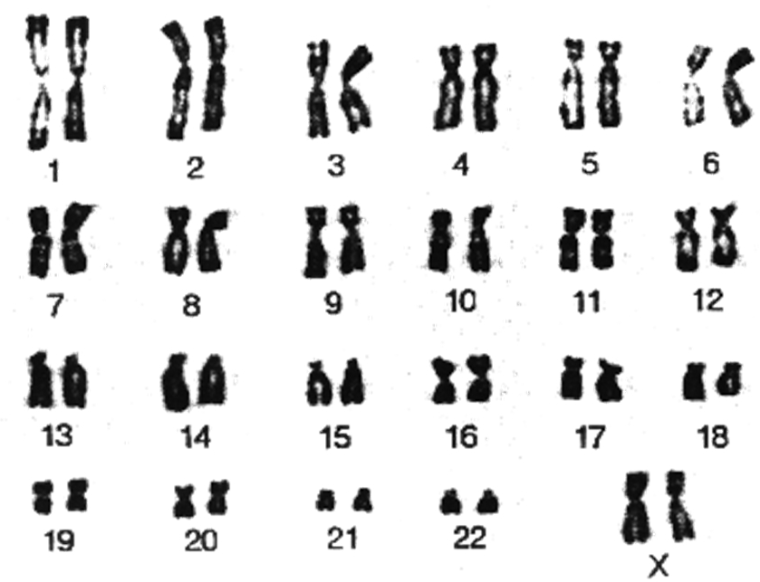
  - a) When chromosomes are arranged in this fashion, it is called a .
  - Write the sex of the person whose chromosomes are shown here.

http://3.bp.blogspot.com

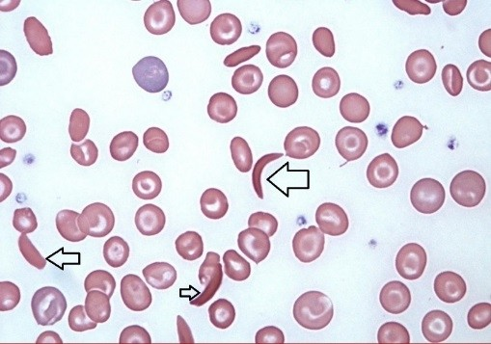
  - a) The slide shows a human blood smear. What is the patient suffering from? (refer to arrows)
    - Is the disease sex linked?
    - Explain the genetic cause of this disease?
    - What is the probability of children being affected by the disease when both the parents are heterozygotes of this gene?

https://s3.amazonaws.com/classconnection

Molecular Basis of Inheritance

  - This is a diagram of a polynucleotide. What does A and B represent? How are nucleotides linked?
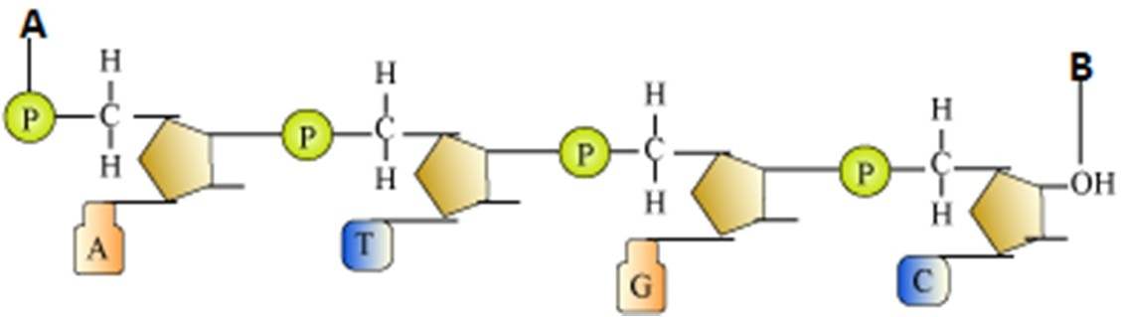

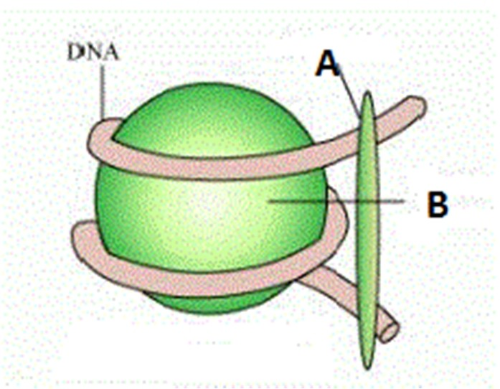
  - 1. Label A and B
  - What is the composition of B
  - What is the length of the DNA wrapped?
  - What is this structure called?

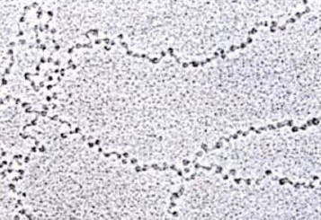
  - a) Identify this picture.
- When such structures can be observed?
- What are the dark round spots seen in the picture?

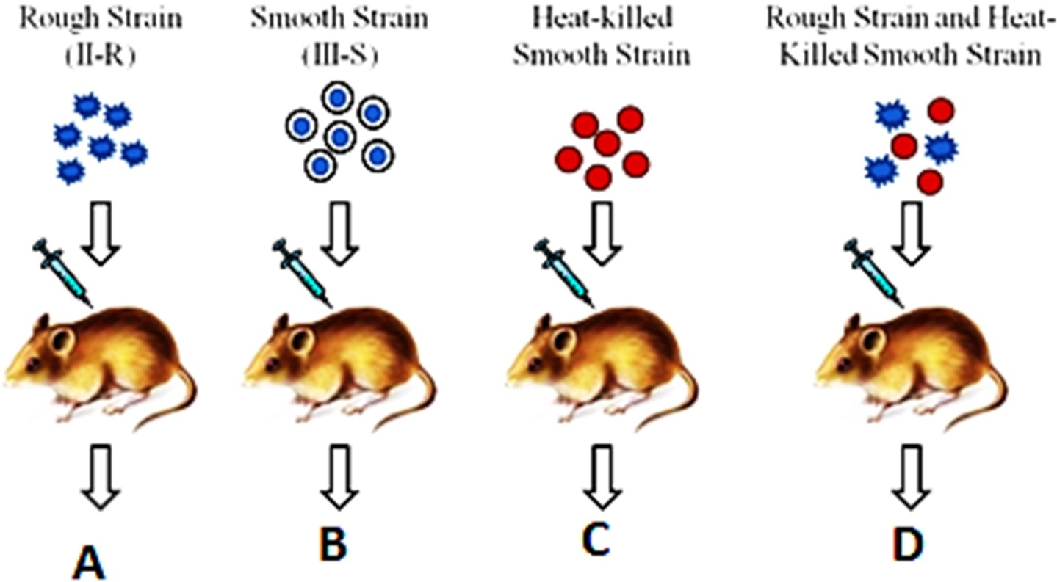
  - Who performed this
experiment? What was the objective? What was the conclusion after this experiment? Write the results of the experiment A-D.

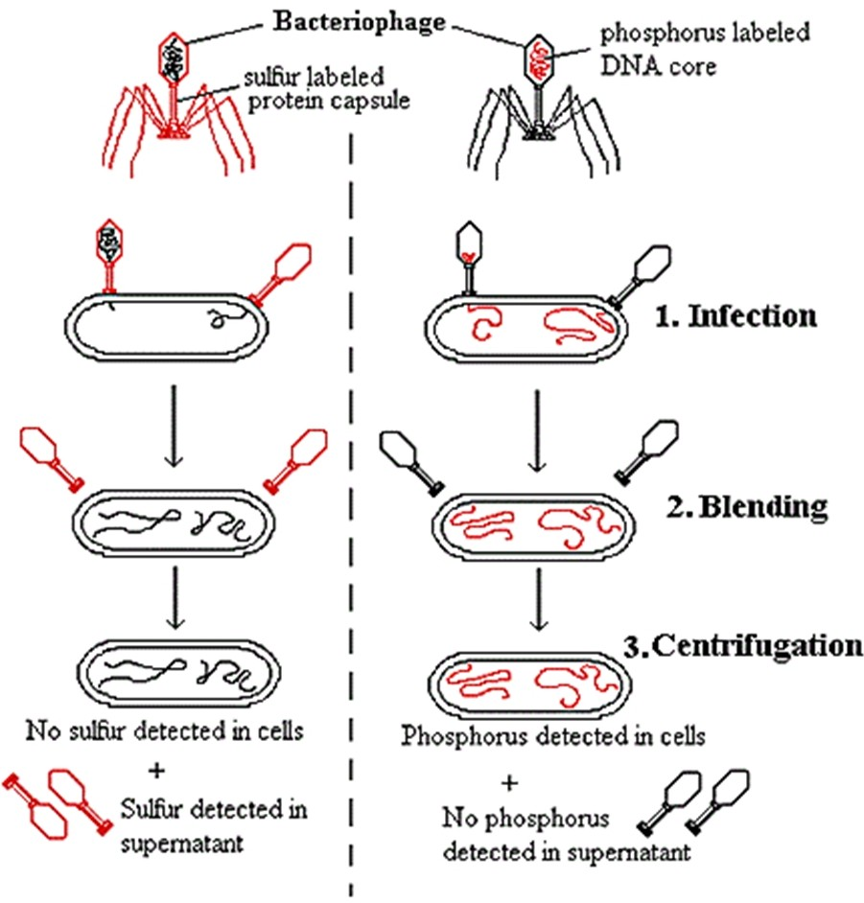
  - a) Who performed this experiment?
  - What was proved by this experiment?

http://www.mun.cabiologyscarrexpt.gif

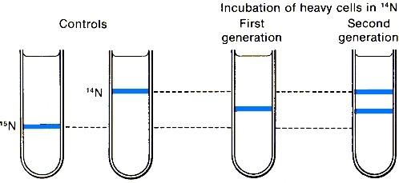
  - a) What was the objective of
this experiment?
    - Who performed it?
    - How was the DNA separated into different layers?
    - Name any other scientist who had performed experiment to prove the same.

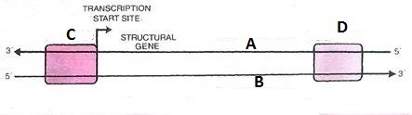
  - What does this diagram
represent? Label A-D

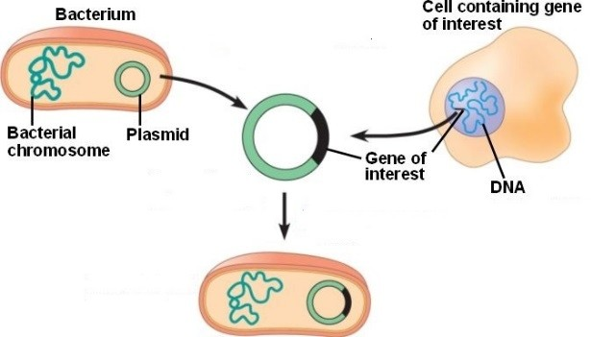
  - Study the diagram and
Elaborate what it explains.

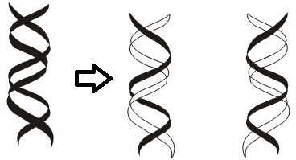
  - a) What does the diagram represent?
b) Can you mention any other model proposed for the same?

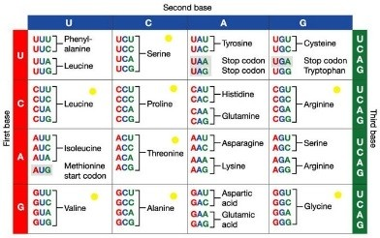
  - a) Mention the ‘Nonsense codons’.
- Which codon initiates translation? Does it have any other function?
- Genetic code is degenerate. Take help of this table to explain it.
- If any mRNA is as written as below then how many Amino acid will the polypeptide contain? 5’ AUGCAGGGUUCAAAAUAGGAUUCCGGACUA 3’

http://www.benntool.com

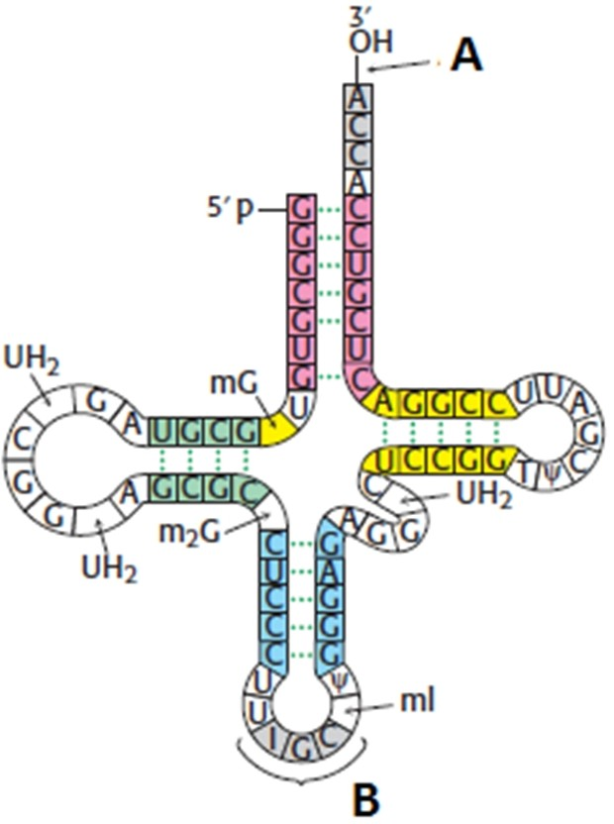
6.11
What does the structure represent? What Is it’s (model) called?
What is the other one? Label A and B.

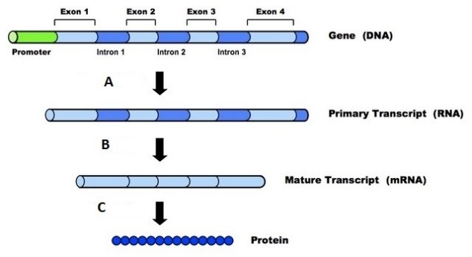
  - Name the three events A-C shown
in this diagram.

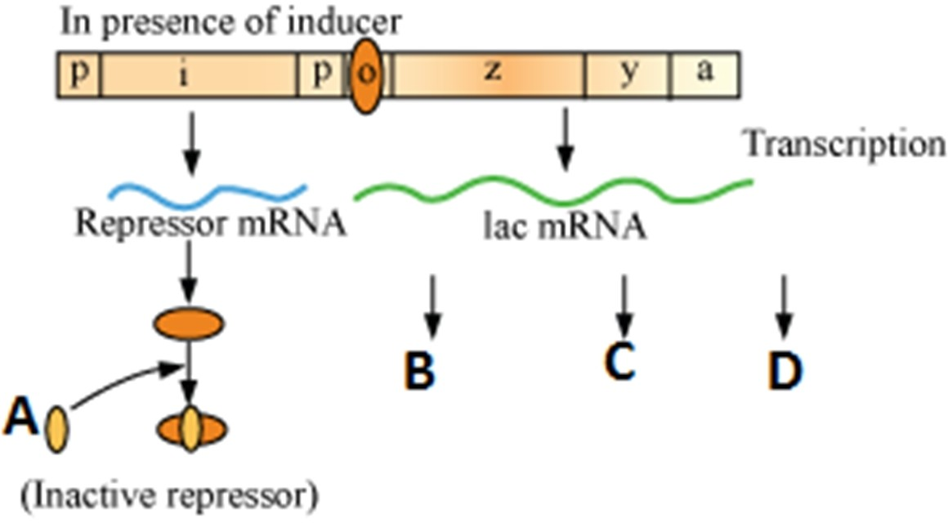
  - a) What is A doing?
  - Label B-D
  - What would happen if A was not present?

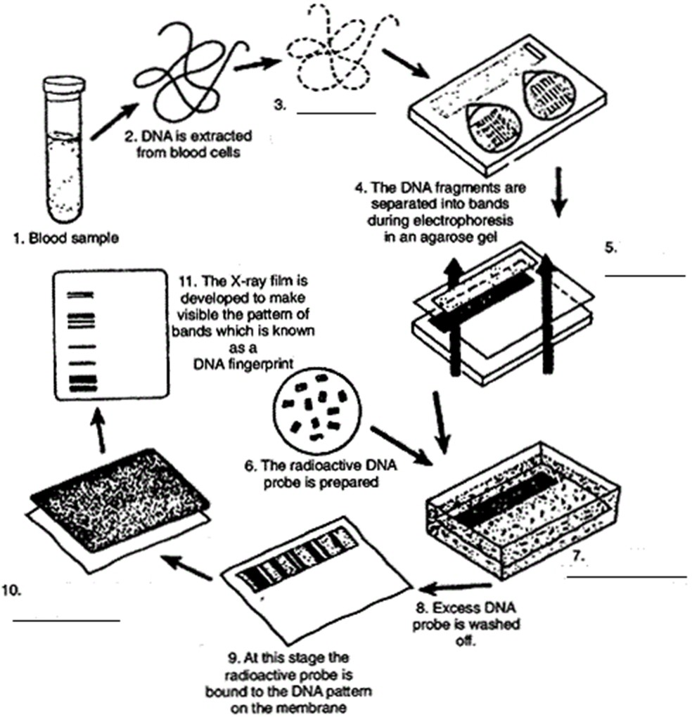
  - The diagram shows steps in DNA
fingerprinting. Some of the steps are unlabeled. Label the steps 3, 5,7,10.

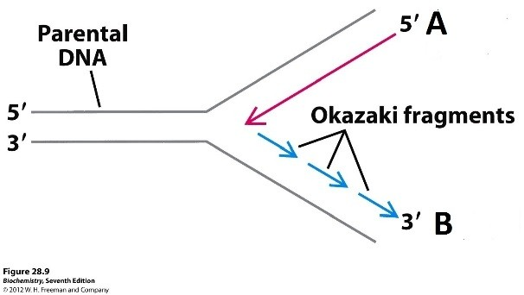
  - a) What is shown in this diagram?
- Label A and B.
- Place Primer (s) in the diagram
- How is the process different in prokaryote and eukaryotes?

6. Evolution
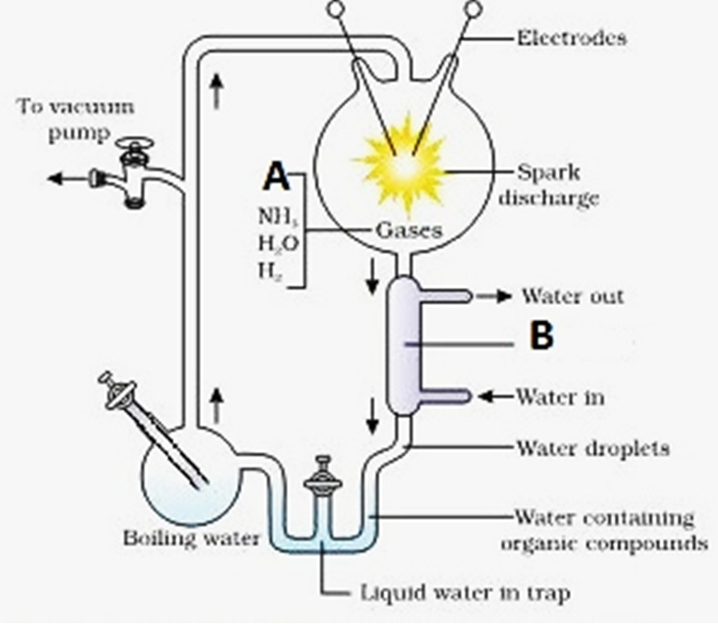
  - a) Label A and B
- Who performed this experiment
- What did he want to prove?

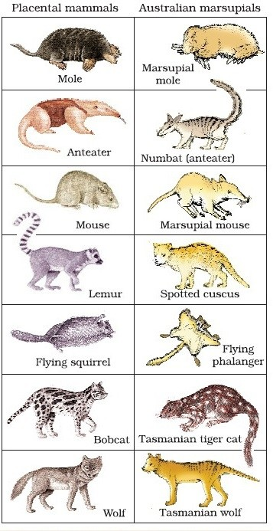
  - a) What does this picture depict?

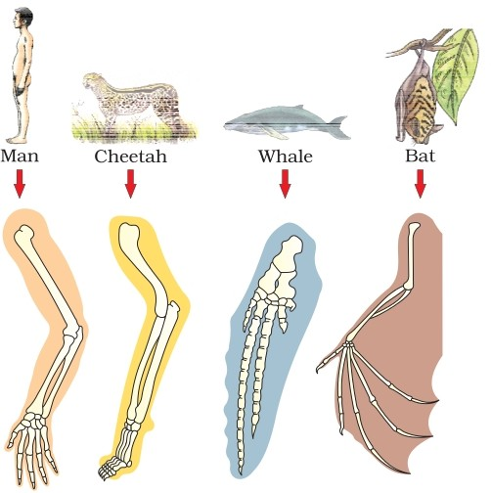
  - What similarity do you find among the four
organisms so far as their forelimbs are concerned? Comment upon it.

  - a) This picture shows Adaptive radiation of
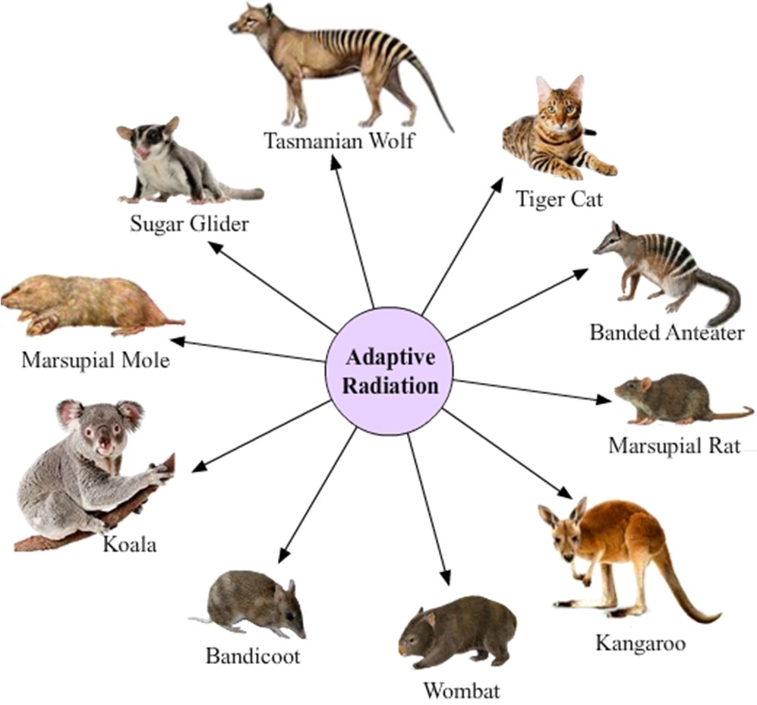
marsupials of Australia. What does it mean?
b) Cite any other example of adaptive radiation.

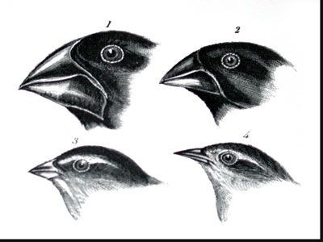
  - This is Darwin’s observation in the Galapagos
island. What did he observe?

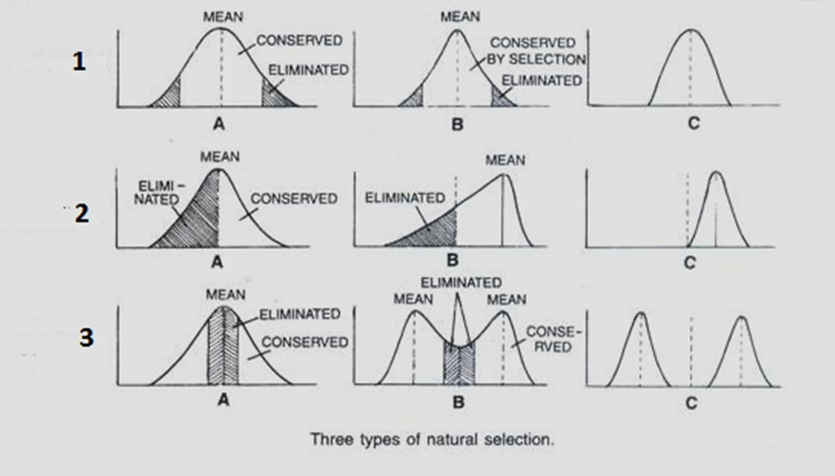
7.6
The diagram shows types of Natural Selection. Study the diagram and write the types 1 to 3.

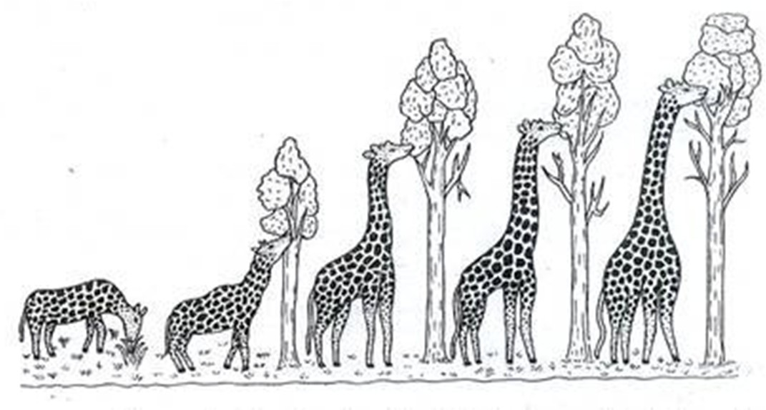
  - Study the diagram and comment upon the concept of evolution

7.8
http://cdn.yourarticlelibrary.com

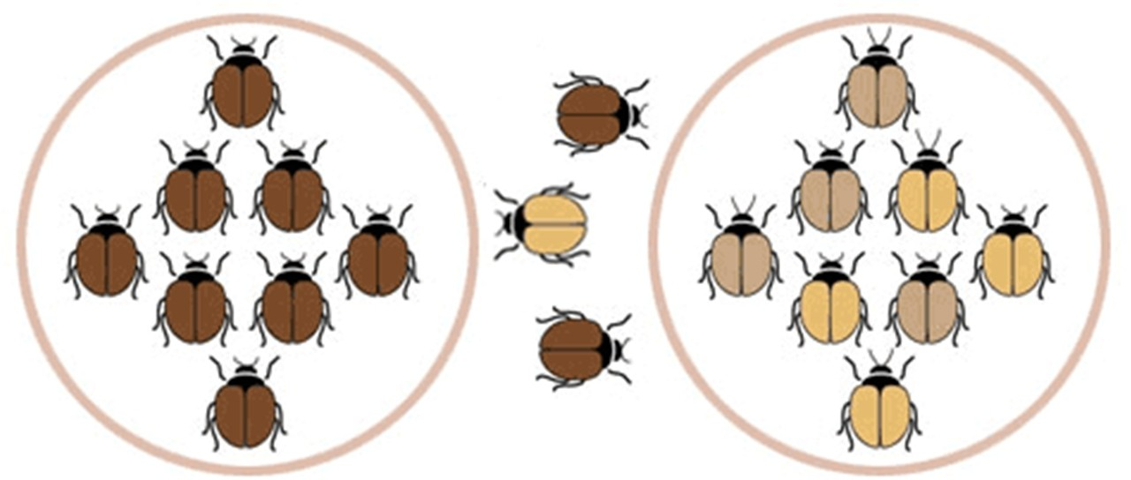
http://1.bp.blogspot.com/-

Study and explain this diagram

7.9

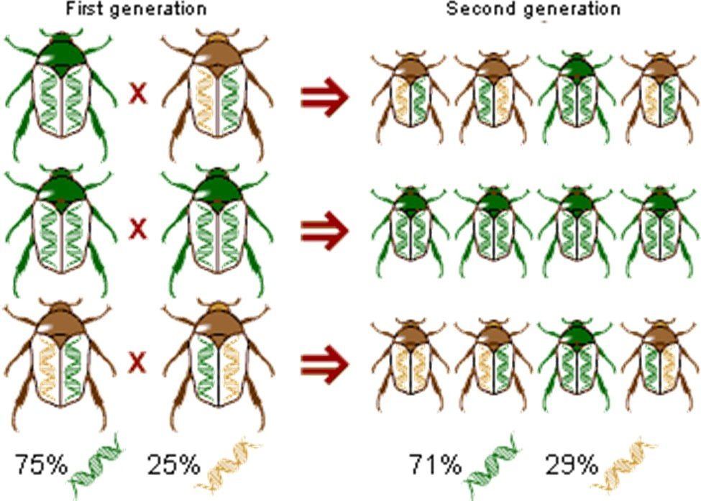

http://gabrielarogers.blogspot.in

What conclusion can you draw from this diagram?

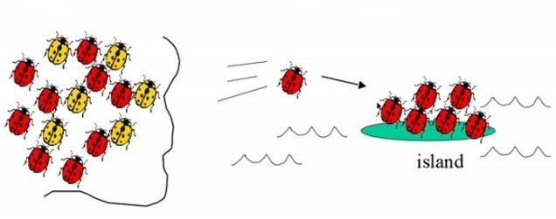
  - What is shown in the picture?
Write technical term for this event.

http://gabrielarogers.blogspot.in

- Human Health and Disease

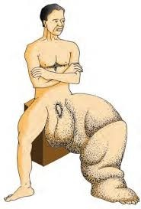
  - Name the disease and the causal organism.

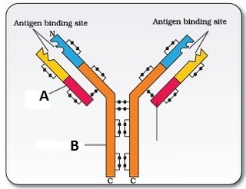
  - What does the carton represent? Label A and B.

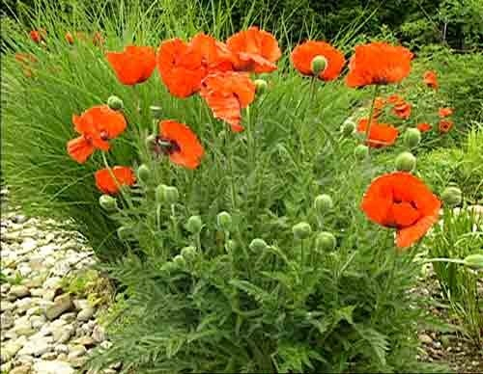
  - a) Identify the plant
- Name the drug obtained from the seeds of this flower. What is it commonly called?
- How is it obtained?

http://www.richardayres.net/garden
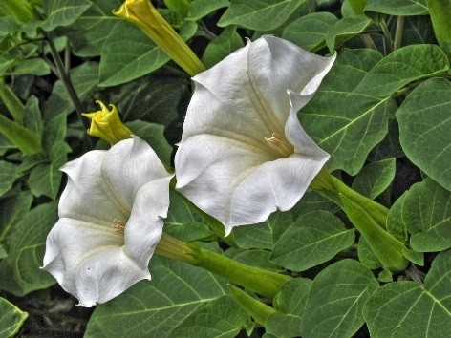
  - This is a common garden flower and also found
growing wild. This plant is associated with drugs related matter. What is it?

http://organic-gardening.site74.com/wp-content/uploads/2012/09/
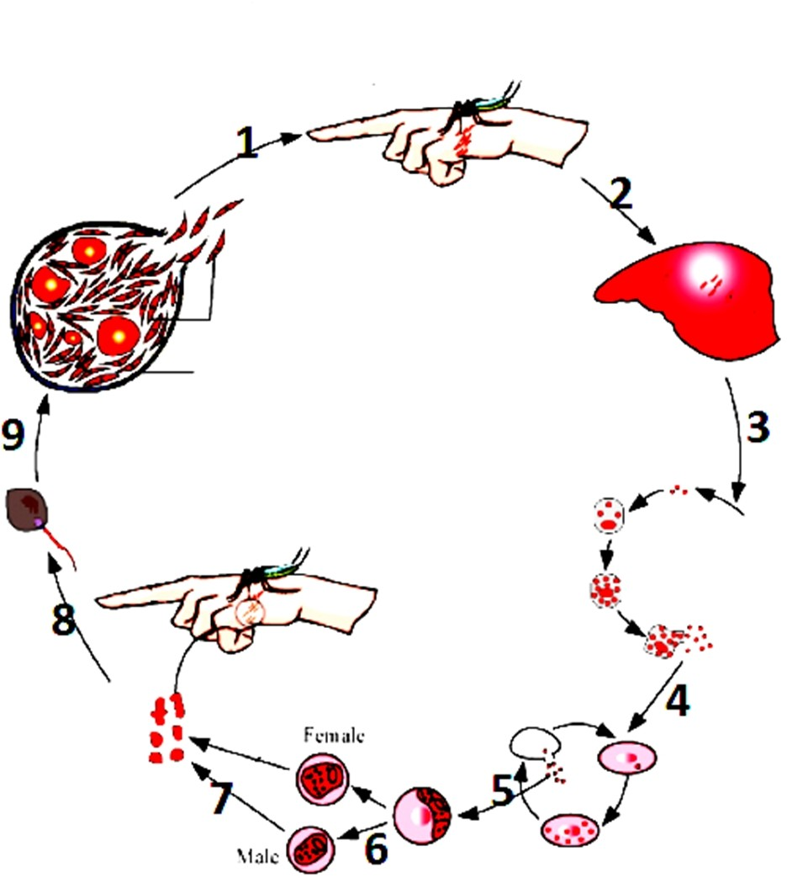
  - The diagram shows the life cycle of the
pathogen causing a human disease.
    - Name the pathogen, Disease and vector.
    - Label the stages 1 to 9

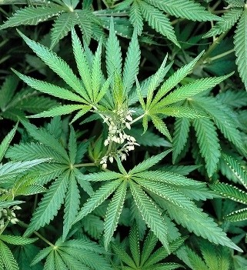
  - a) This is a photograph of a common plant abused for drug. Name the plant.
- Which part of this plant is used as drugs?
- What are the different forms of drugs obtained from this plant?

Strategies for Improvement in Food Production

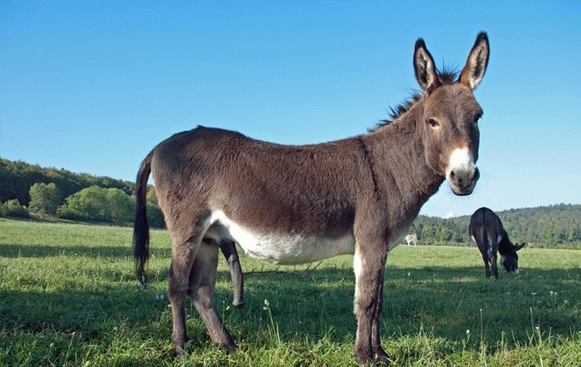
9.1 Identify this animal. How was it developed?

http://www.interestingfunfacts.com/files/2012/04/mules.gif

Microbes in Human Welfare

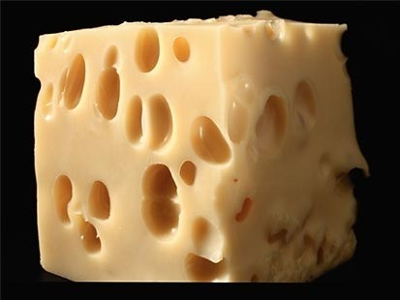
  - a) Why do you find big holes in the piece of cheese shown in the diagram?
b) Name the type of cheese.

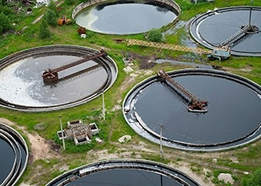
  - a) What does the diagram represent?
b) Explain in brief the process going on.

http://analyzemycareer.com/Careers/ooh/images/p30-to-p31/p304-1-jpg.jpg

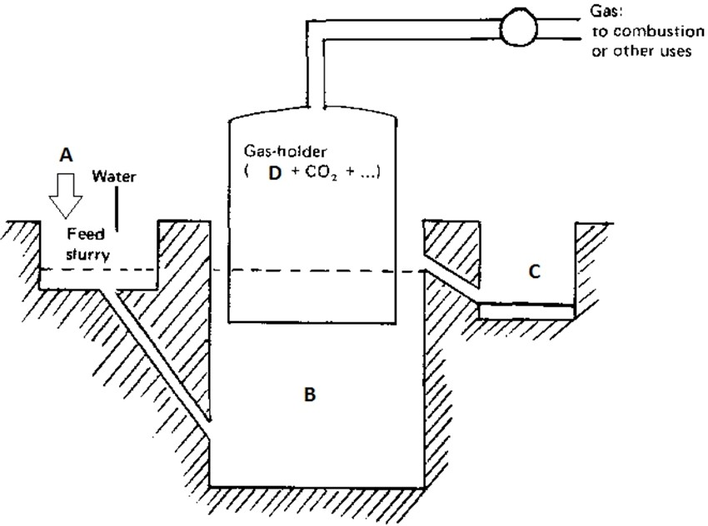
  - This is a diagram of a Gobar gas plant. Label A to D.

Biotechnology: Principles and Processes

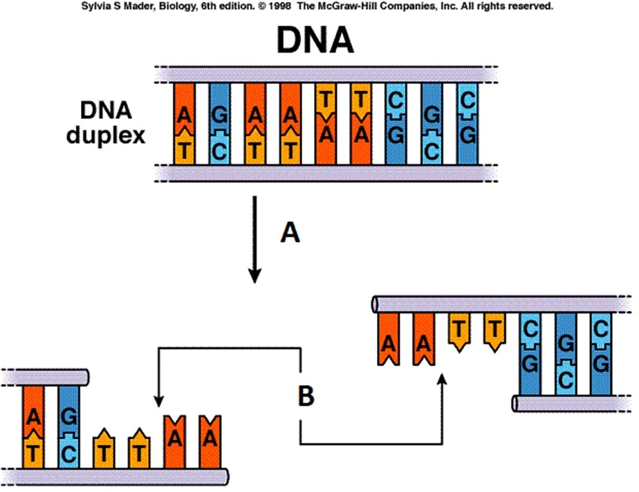
  - a) Label A and B
b) When such process/ event is required?

  - 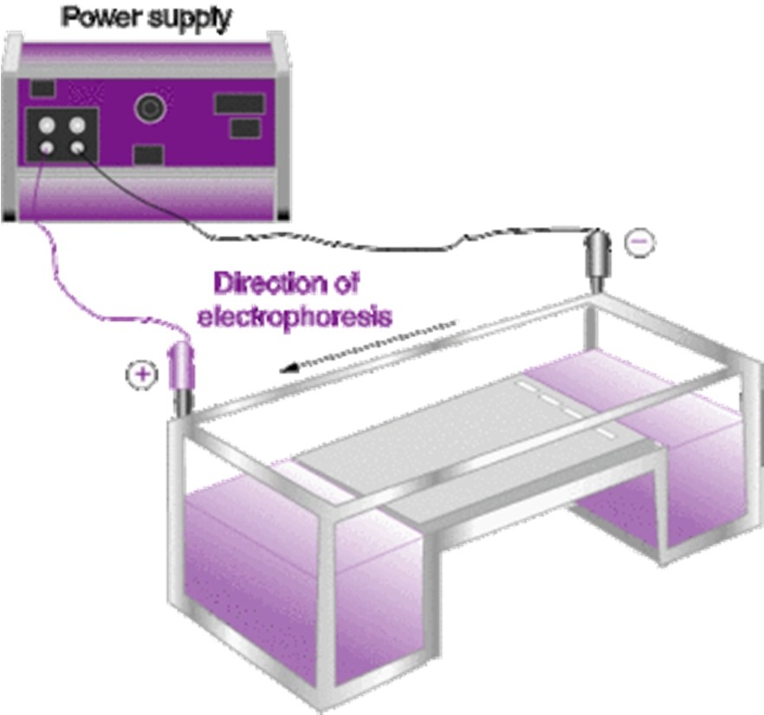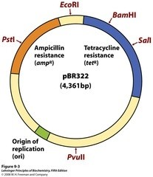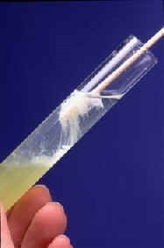The diagram shows a setup for electrophoresis.
    - Why is it needed in experiments in Molecular Genetics or Biotechnology?
    - Write the principle behind working of this apparatus.

  - This is a diagram of a plasmid.
    - Name the RE required to cut a tet^{R} gene.
    - What will happen if a foreign gene is inserted into the tet^{R} locus?

  - a) Name the enzymes used to isolate DNA by breaking the cells of fungus, plant and bacteria.
  - How is DNA isolated in the laboratory?

http://www.biologyjunction.com/images/clip0201.jpg

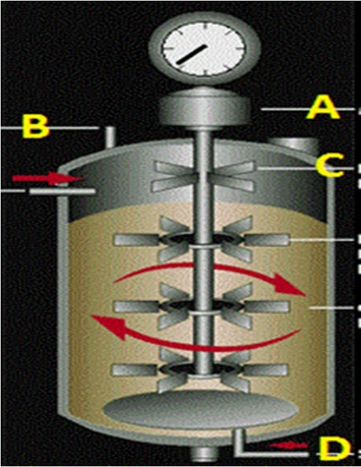
  - Name the instrument. Label A to D.

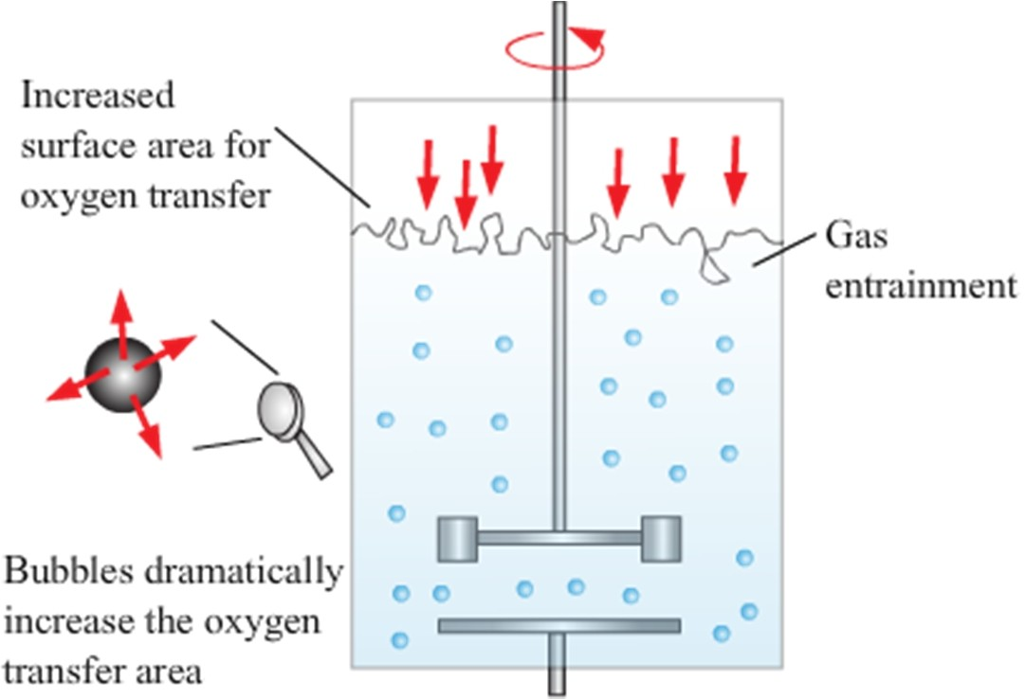
11.6

What is this instrument used for. Explain the principle.

Biotechnology and its Applications

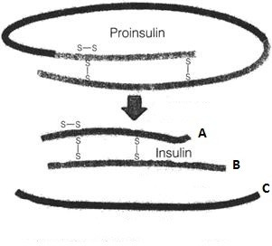
  - a) Explain how Insulin is produced.
    - What was the problem initially felt while insulin was produced using rDNA technology.
    - How was the problem solved?

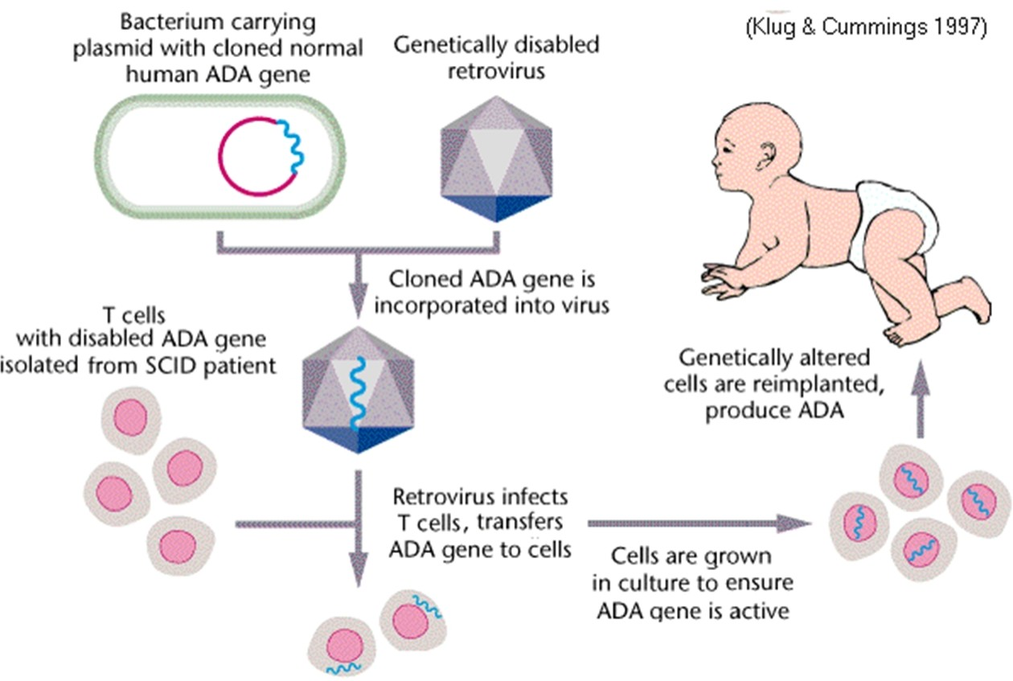
  - Study the diagram properly and
answer the questions.
    - What is this type of treatment called?
    - Name the other methods used for treatment.
    - What is the limitation of this treatment?

http://www.vialattea.net/spaw/image/biologia/SCID.gif

Organisms and Populations

13.1

Introduction of goats in Galapagos Islands caused extinction of this animal. Name this animal

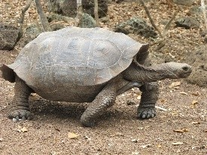
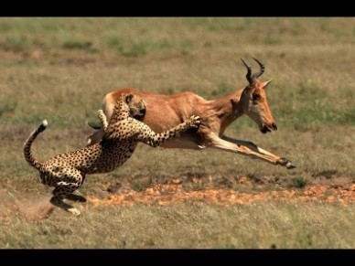
  - This is an example of predation.
    - If tigers / carnivores stop eating animals, herbivores will be saved. Comment upon the statement.
    - If they don’t stop eating animals, a day will come when there will be no herbivores. Justify.

http://i.ytimg.com/vi/8tMtdYPwdno/maxresdefault.jpg

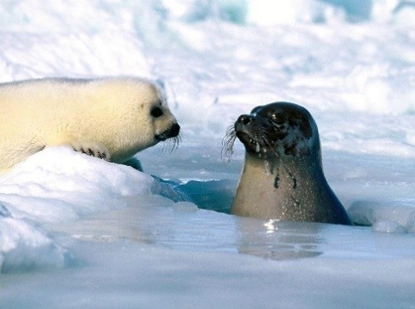
  - How do these animals survive in such cold waters?

http://www.pre-tend

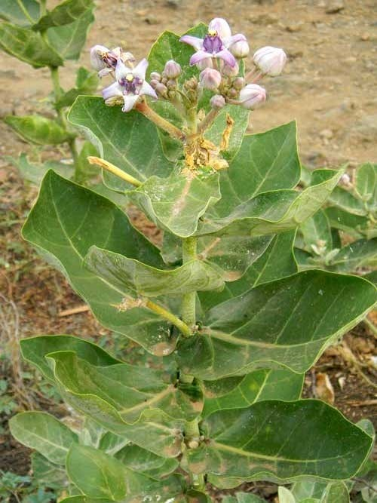
  - a) Identify the plant.
- Why cattle avoids browsing this plant?
Name any two such chemical produced by plants for its protection but commercially used by human.http://www.ngkenya.com/photos

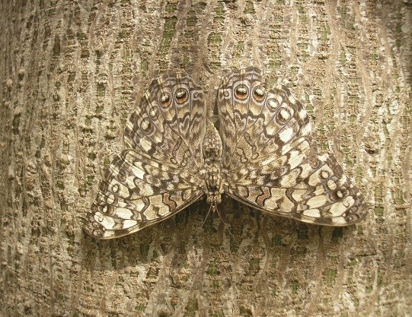
  - Can the animal easily be spotted?
    - If no, Why?
    - Give technical term to this phenomenon. Why animals do such?

http://wonderopolis.org/wp-content/uploads

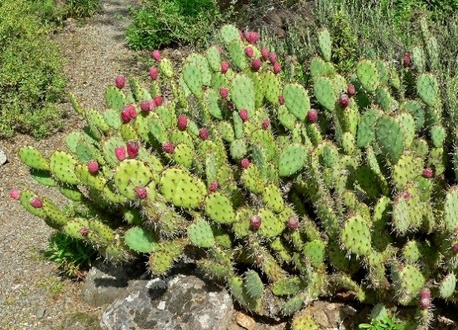
  - This plant was introduced in Australia in 1920s and later became invasive spreading over millions of hectares of rangeland.
    - Why it spread so fast?
    - How was it controlled? Name this plant.
https://upload.wikimedia.org/wikipedia/commons

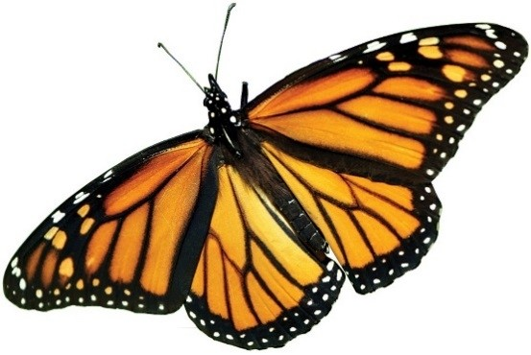
  - This butterfly is highly distasteful to its predators (birds).
    - Name the butterfly
    - Why is it distasteful?
How did it develop such characteristics?
http://www.hcn.org/issues/46.5

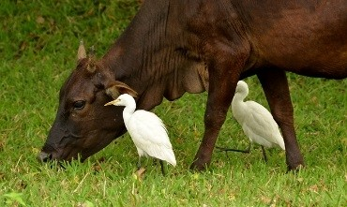
  - a) What type of interaction do you find
here?
  - Define the type of interaction.
  - Cite any other example.

13.9

http://cdn.ipernity.com/121/82/90/12168290.ab8b3464.640.jpg?r2
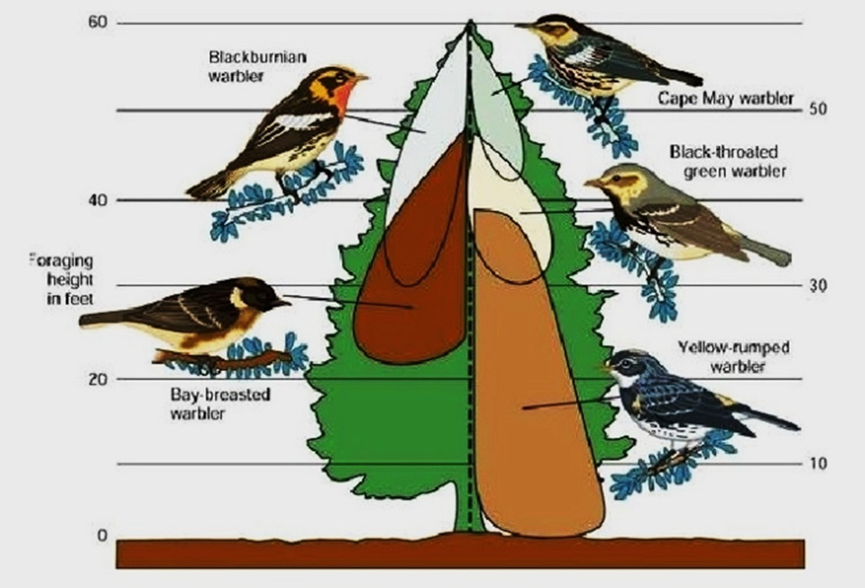
http://image.slidesharecdn.com/biological-communities-and-interaction-

It is an observation made by Mac Arthur.
- What was the observation?
- Give technical term to it?
- Why do birds behave in this way?

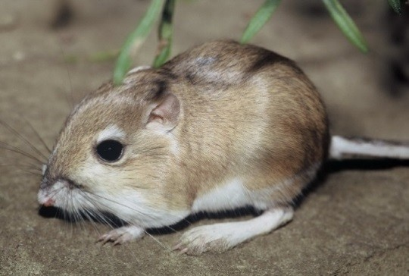
  - This is a picture of a Kangaroo rat living in North American desert.
    - How does it survive there?
    - Write any 4 features developed in plants for survival in deserts.
http://www.cbc.ca/morningedition

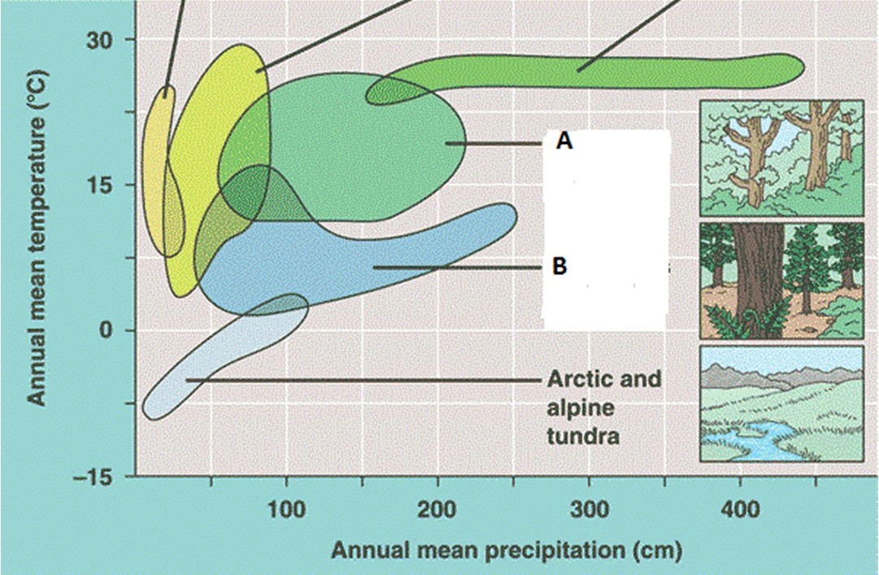
  - The diagram shows Biome distribution
with respect to annual temperature and precipitation. Label A and B.
Modified from:

http://www.quia.com/files/quia/users/lmcgee/ecology/climograph.gif

13.12

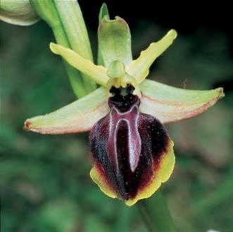
http://vignette3.wikia.nocookie.net/orchids

What is sexual deceit? How does it apply to this flower?

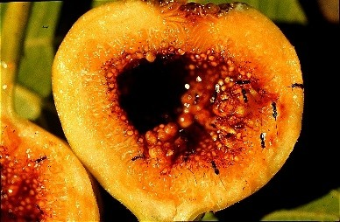
  - a) What do you find in the picture?
b) Mutualists should co-evolve. Why?
Why do you call them mutualists?

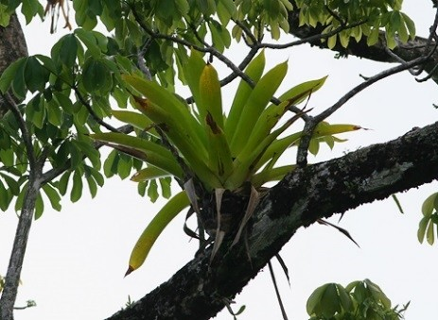
  - a) A plant growing on another plant causing no harm is called
b) This type of interaction is called Give term to the interaction where one is not benefitted and other is in loss. http://fireflyforest.net/images/firefly/2006/July/bromeliad.jpg

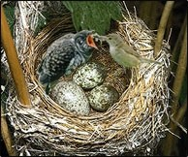
  - a) What specific term can you propose to explain egg laying relationship between a crow and a cuckoo (koel)?
b) Is it a parasitic relationship? Why?

http://www.indianmirror.com/wildlife/birds/images/cuckoo-nesting.jpg

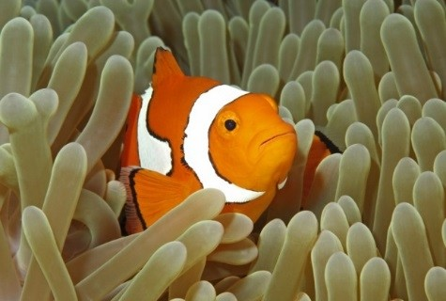
  - Interaction between Clown fish and Sea
anemone is called Commensalism. Who is benefitted in this association and how?

http://learnaboutsymbiosis.weebly.com/uploads/2/8/8/4/28842393/1148777_orig.jpg

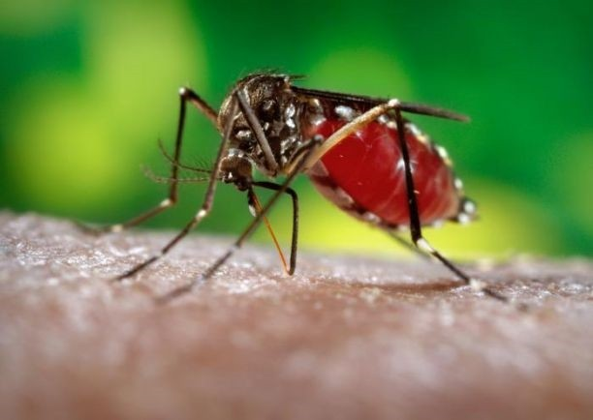
  - In this picture a Female mosquito is biting a
man and drawing blood. Is it parasitism? Justify.

http://uanews.org/sites/default/files/styles/blog_image_large_600px_w/public/story- images/AedesAegyptiMosquitoBite1.jpg

Ecosystem

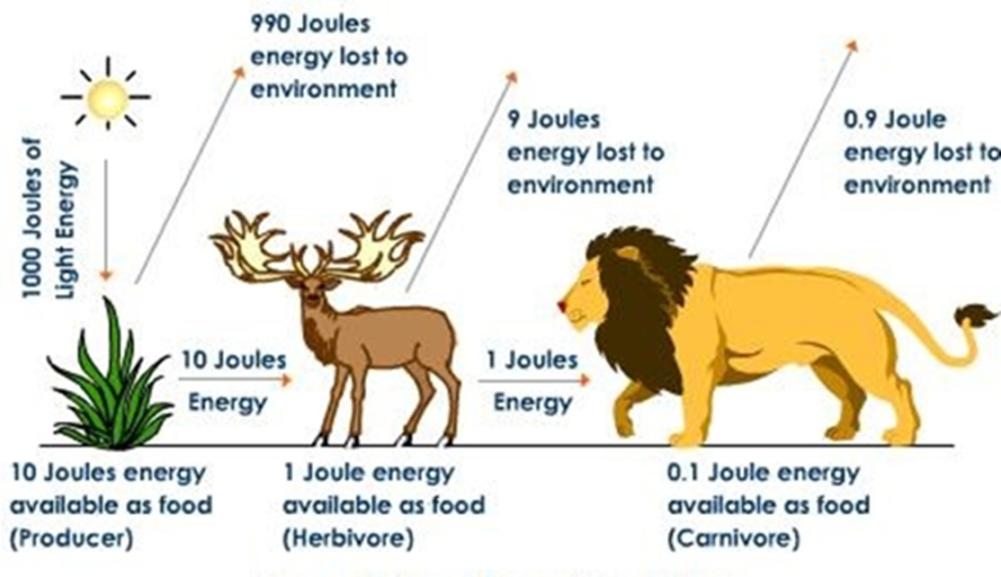
14.1
On the basis of amount of energy transferred what does this picture represent? Draw an ecological pyramid based on this diagram. Name it.

http://images.tutorvista.com/content/ecosystem/progressive-energy-loss.jpeg

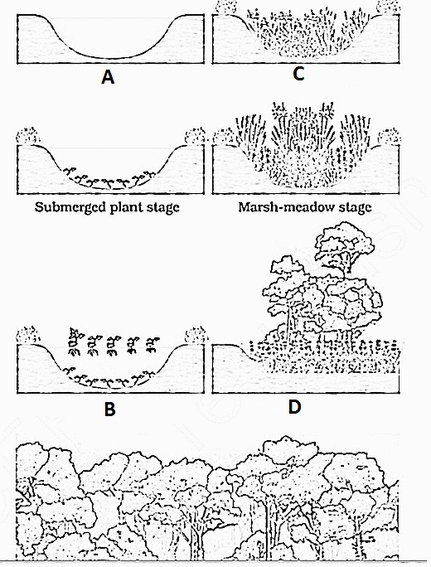
  - a) What is the technical term for succession in a pond / water body?
  - Label the stages A – D
  - What is Secondary Succession?

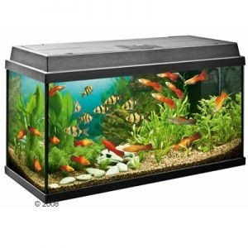
14.3
    - Name any other man made ecosystem.
    - What are the aspects you should consider to term any ecosystem to be self-sustainable.?

http://www.bc-elec.com/media/catalog/category/aquarium_1.jpg

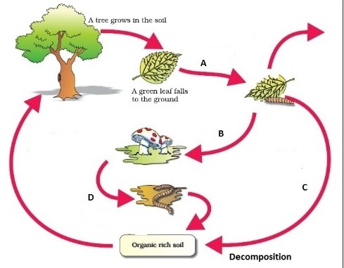
14.4

Study the diagram and describe in brief the process with special reference to points marked a-d.

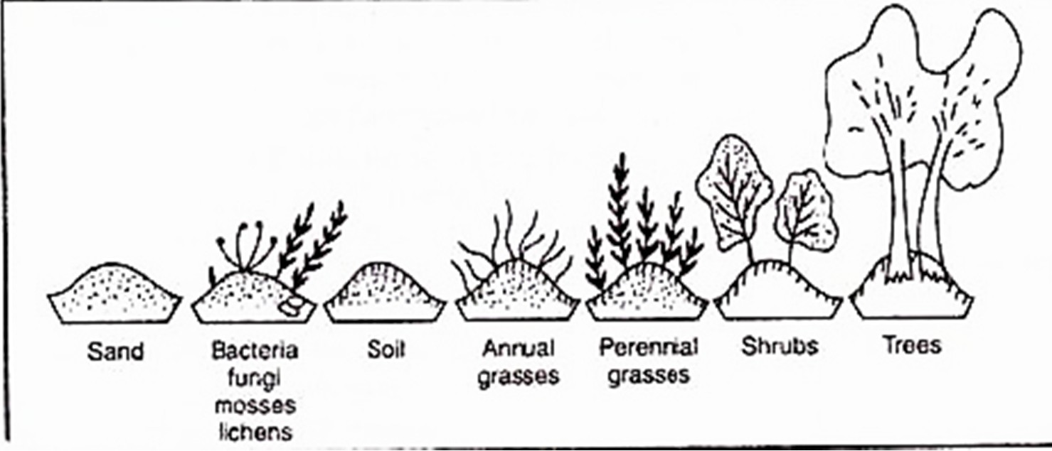
  - What is shown in
this diagram? Explain in brief.

http://www.biologydiscussion.com/wp
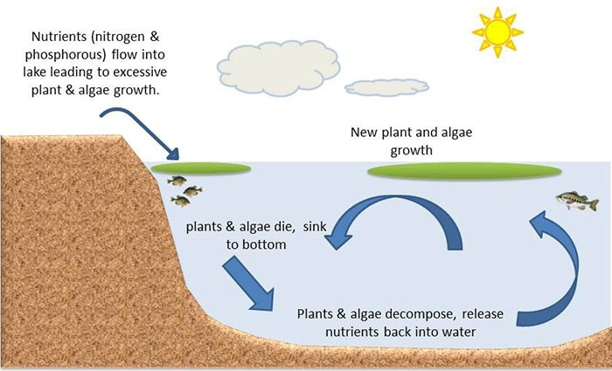
  - The diagram shows a section of a pond
where certain events are shown to occur. How can you say that this ecosyatem can function as an unit?

https://njaes.rutgers.edu/pubs/fs1231/FS1231-2.jpg

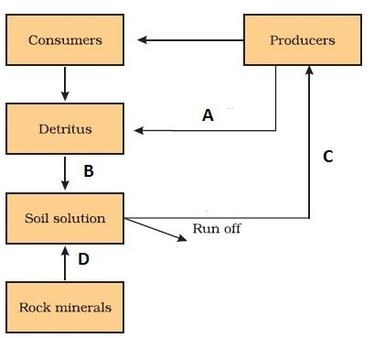
  - This is a simplified model of Phosphorus
cycle in a terrestrial ecosystem. Label A to D.

- Biodiversity and Conservation

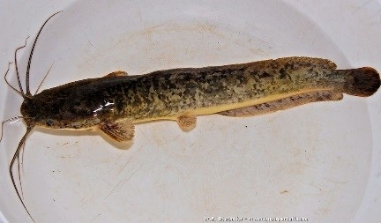
  - When this catfish was introduced into
Indian rivers, it posed a threat to Indian catfish. Name the fish. Give the specific term for such event.

http://www.aquaportail.com/aquabdd/photos

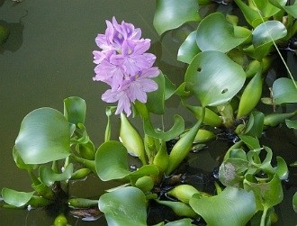
  - a) Identify the plant and write the scientific name.
What was the result of introduction of this plant?

Match the animals with their names
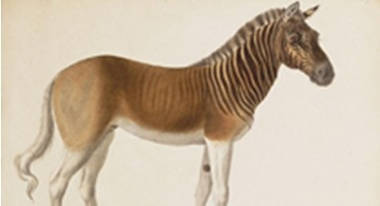 | 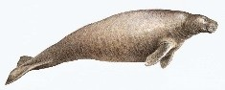 | 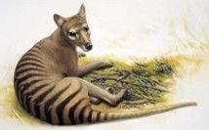 | 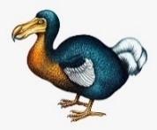
A | B | C | D
Hints:

Dodo/ Stellars Sea Cow / Quagga / Thylacine/

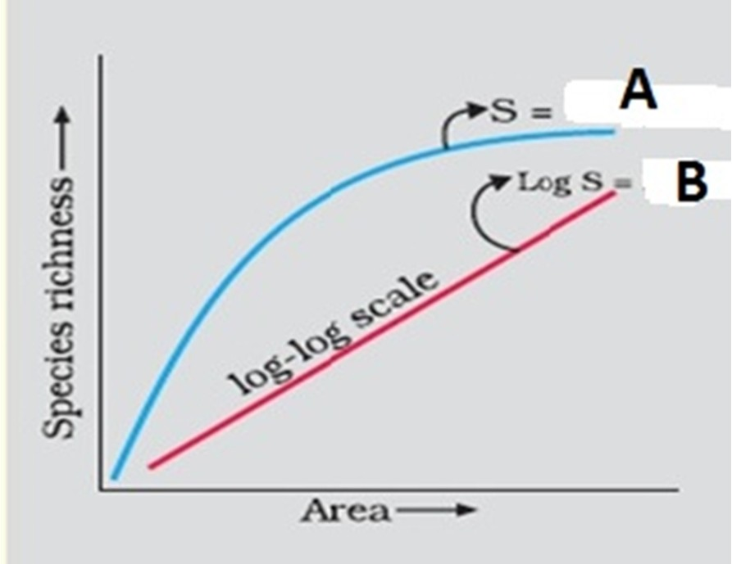
  - Study the graph and answer the questions.
    - Name a scientist who studied species richness in the South American jungles (as in your text book).
    - Complete the equations A and B
    - How does the value of Z differ? Give example.

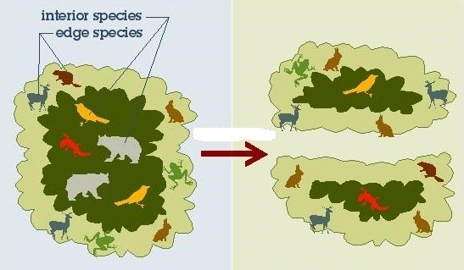
  - a) What does the diagram represent?
      - Explain the effect.

http://wildflowerturfblog.wildflowerturf.co.uk/wp-content/uploads/principles8-12n4vvp.jpg

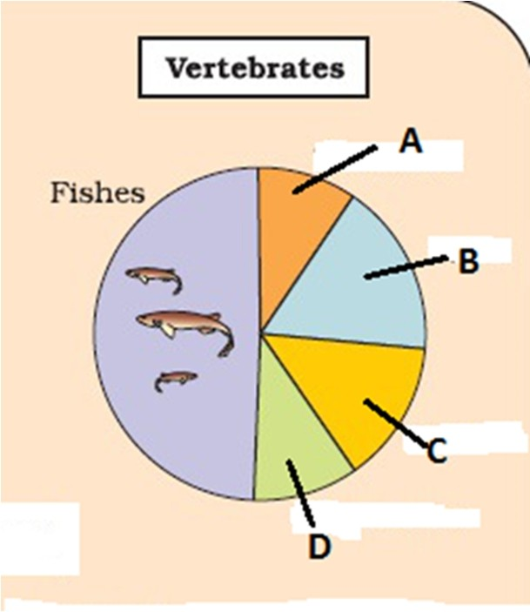
  - The figure represents Global Biodiversity of Vertebrates in proportionate number of species. Identify A to D from the hints below.
Hints:
Amphibians Reptiles Birds Mammals

Environmental Issues
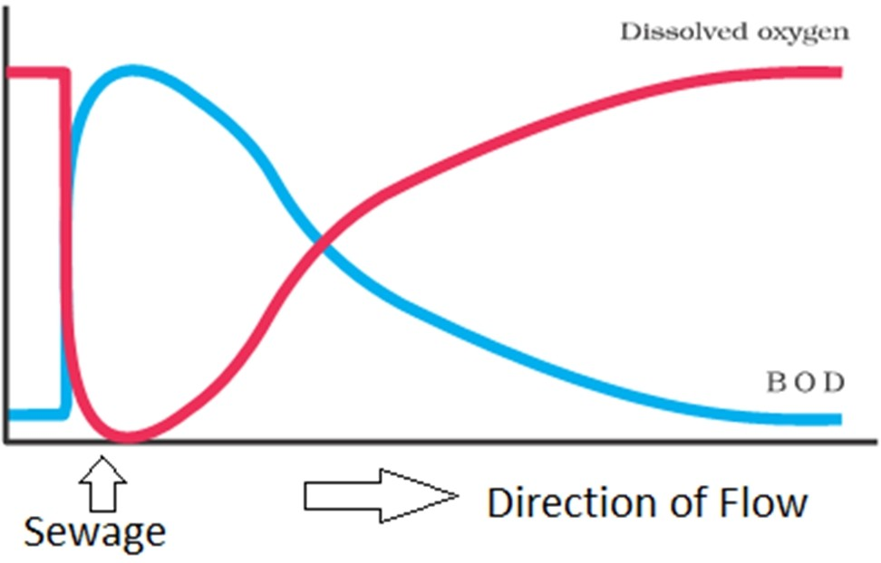
  - While studying the purity of the flowing river
water, Mr. Ram drew the graph. Explain the graph (giving reasons) before and after the point where sewage was discharged in the river.

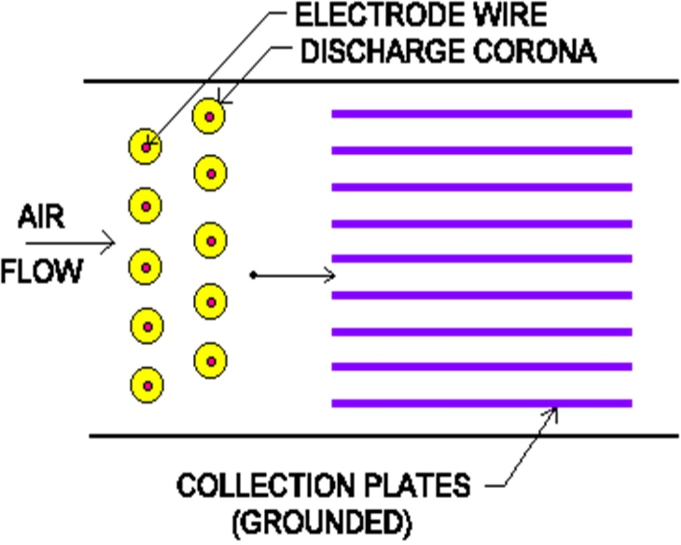
  - a) What does this picture represent?
        - Explain the principle of it’s working.

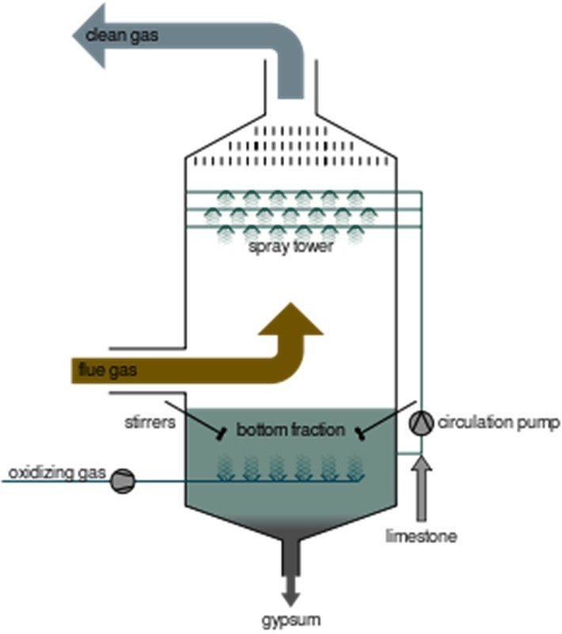
  - What is the use of this apparatus? Explain the process.

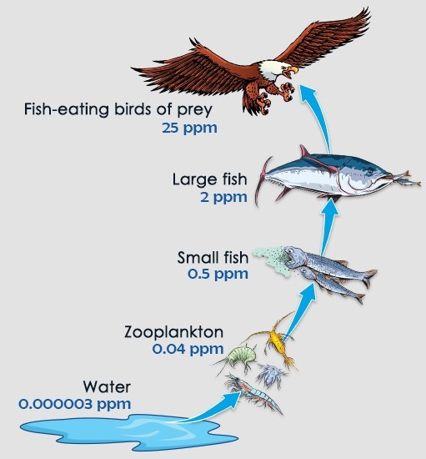
  - What does the diagram represent? Define the term. Why does such happen?

http://www.buzzle.com/images/environmental

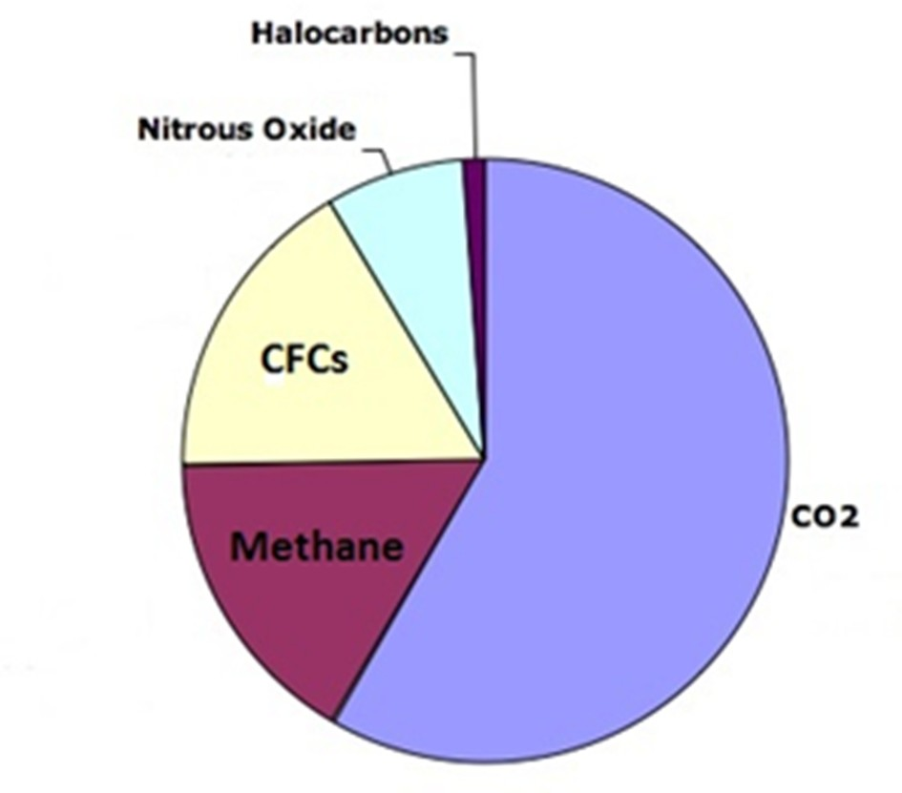
  - Select the correct option:
    - CFC (14%), Methane (20%)
    - CFC (20%), Methane (14%)

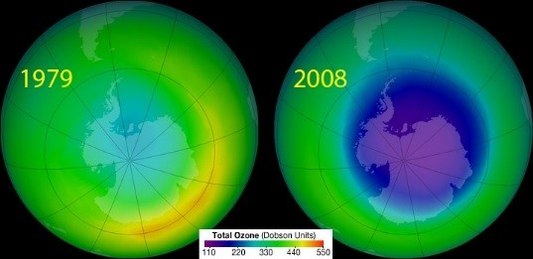
  - a) What is shown in this picture?
          - What is the cause?
          - What is the effect on human beings?

https://sriutami88.files.wordpress.com/2012/02/

  - Give a suitable caption for this image. What is the cause for this situation

16.8

What is this drive taken by the Government of India?

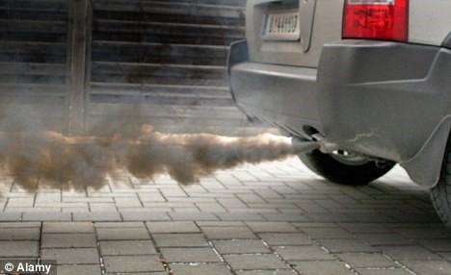
  - How has the Delhi Government reduced such
pollution?

http://i.dailymail.co.uk/i/pix/2011/02/07/article

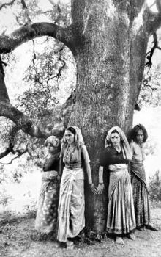
  - a) What reminds you seeing this picture?
b) Give a brief history

http://healingearth.ijep.

